Proteins
Some proteins function as Enzymes
Enzymes speed up chemical reactions

How do enzymes work?

Activation energy = the amount of energy needed to start a chemical reaction

Enzymes LOWER the activation energy.

Chemical reactions put things together or break them apart

Example

A synthesis reaction
Molecule “A” + molecule “B” = molecule “C”
Or
A decomposition reaction
“C” = “A” + “B”

Glucose + Fructose Sucrose
Sucrose Glucose + Fructose

Reactants are what you start with (circle)
Products are what you end with (underline)

The shape of an enzyme gives it its specific function

Examples:Sucrase breaks down sucrose. 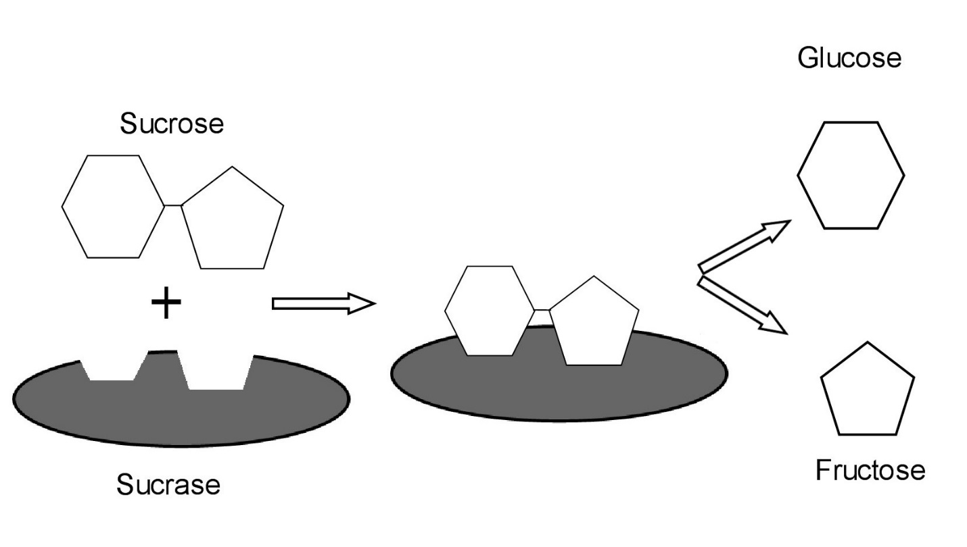

CHANGE the SHAPE of an enzyme IT STOPS WORKING

Denature – to destroy the shape of an enzyme

What can denature a protein?
HEAT or COLD
pH change
Chemicals

What gives an enzyme its shape?
The 4 structures of Proteins
Primary structure – the chain of amino acids
Secondary structure – hydrogen bonds between amino acids
Tertiary structure – permanent bonds between amino acids
Quartenary structure – 2 or more chains coming together
Vocab – HYDROGEN BOND – a weak bond between molecules
Examples – water, amino acid, DNA

