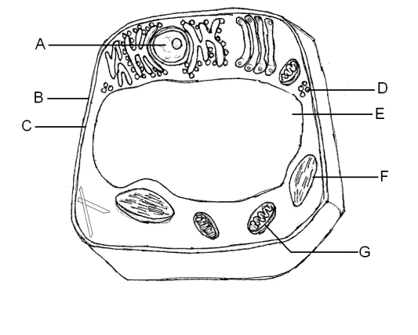
- Label A-G. What type of cell is it? (2 answers)

- These nerve cells are specialized cells in order to carry electrical messages through the body. How do cells become specialized and different even though every cell in your body has the exact same DNA?

C. What type of cell is this ? 2 answers D. What organelle is shown below?
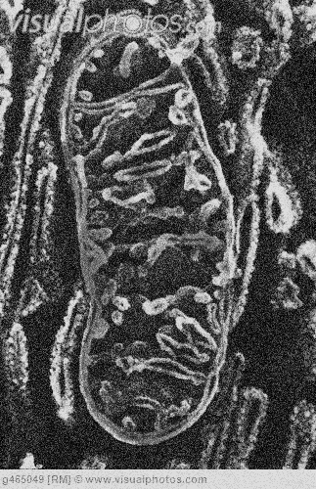
Name the 4 structures it shares with every other cell. What is its function?
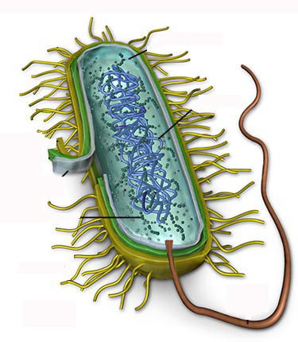

E.
What is the structure above? What is its function?

F. What type of cell is below (2 answers)? What is the function of the ER? Golgi body? Lysosome? Ribosomes? Nucleus? What does NOT have compared to a plant cell?
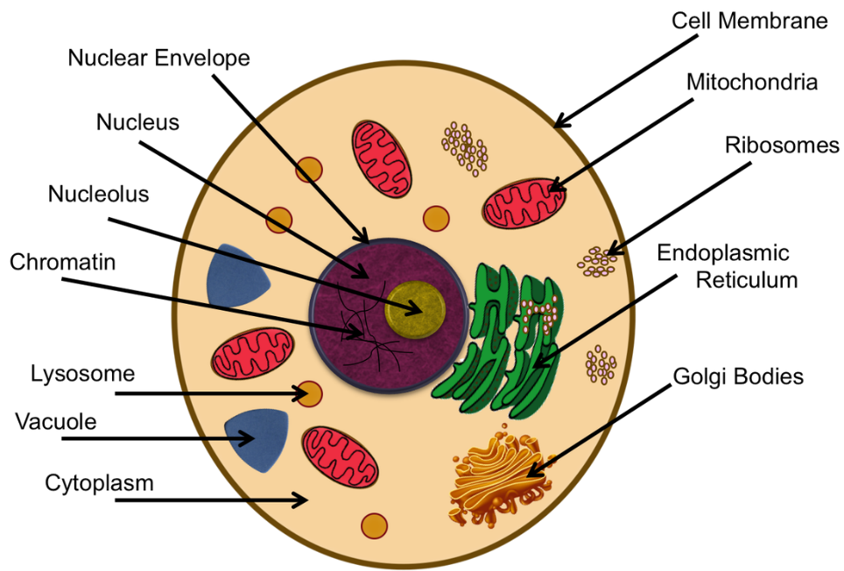
G.
Part | Prokaryotic | Eukaryotic | Plant | Animal
Nucleus |  | YES | YES
Cell membrane | YES |  | YES
Cell Wall |  | SOME |  | NO
Organelles | NO
Ribosomes |  | YES |  | YES
Mitochondria |  | YES | YES
Cytoplasm | YES
DNA |  |  | YES | YES
Chloroplast |  | SOME |  | NO
Large Vacuole |  | SOME
Cell Wall |  | SOME | YES

