Diffusion and Osmosis
Vocab:
- Solute – molecules that are dissolved in water
- Solvent - the water that does the dissolving
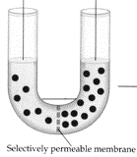
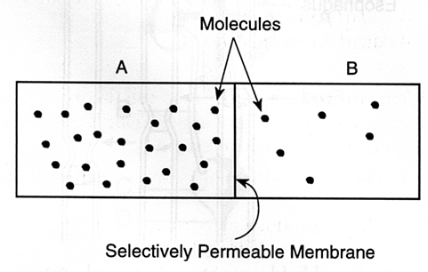
Problems:

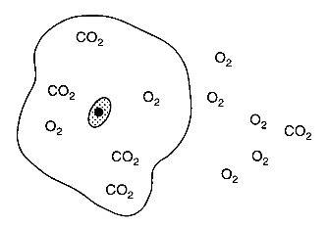
A cell with a 9% solute concentration is placed in a beaker with a 2% solute concentration. What will happen to this cell over time if only water can move across the membrane?

