- Which statement best explains section X?
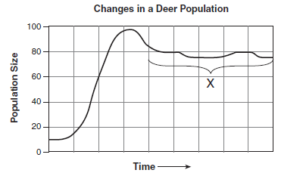
- The population has reached the carrying capacity of its environment. B. Energy is used for interbreeding between members of different species. C. A predator recycles the remains of dead organisms D. Competition does not occur between members of different species in the same habitat.
- The trend shown on the graph would most likely result in what?
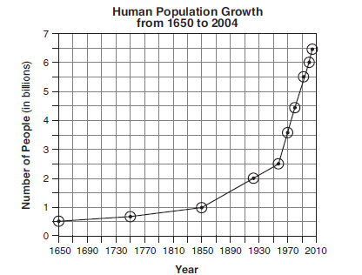
A. a decreased demand for deforestation B. an increase in available freshwater C. a decrease in air pollution D. an increased demand for land use
3. What is the most likely cause of the decline in the population of Elm trees?
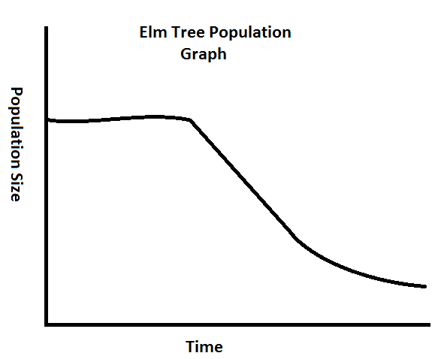
A. An increase in the amount of space for Elm tree habitats B. A decrease in the amount of deforestation C. Introduction of a competitive species of tree. D. Introduction to a disease causing agent such as a fungus.
4. All of the following statements concerning characteristics of predator-prey relationships are correct EXCEPT:
A. The population of predators most often eliminates the population of prey B. The production of large numbers of offspring within very short periods of time ensures the survival of some prey populations. C. Camouflage is an adaptation that protects prey. D. A rise in the population of predators is followed by a decrease in the population of prey. E. A rise in the population of prey is often followed by a rise in the population of predators.

