1. 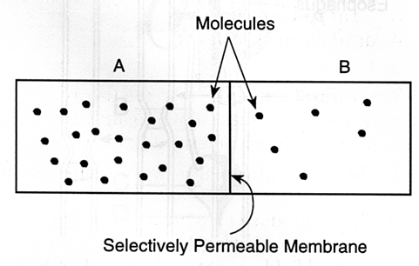 Osmosis will occur toward which side. Which side has a higher concentration of solutes?
2. Which side has more solutes? Which side has higher water concentration? Which way will osmosis occur? Where will the water be higher?

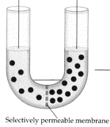

1. 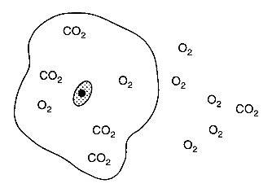Which gas is higher concentrated inside the cell? Where will oxygen diffuse? Where will carbon dioxide diffuse?
2. For each row answer with either active or passive transport.

Row 1:

Row 2:

Row 3:

Row 4:

Which row is considered diffusion?



1. Which cell is showing active transport?

Which cell is showing diffusion?



1. Are the squares (glucose) going from high to low or low to high?

Is high to low movement considered diffusion?

Is diffusion passive or active?

Since it is getting help from a protein because it is too big it Is considered what type of diffusion?

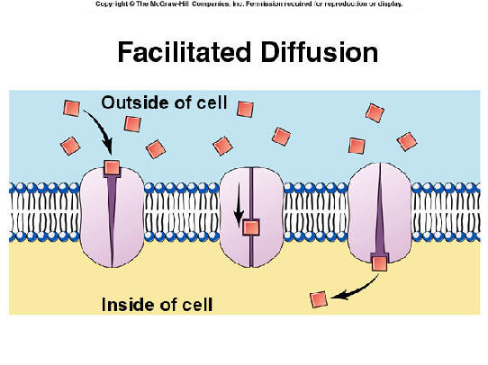

1. Oxygen ____________________ into the cell from ________ to ________.

Can proteins pass through the cell membrane?

Which molecule is at equilibrium?

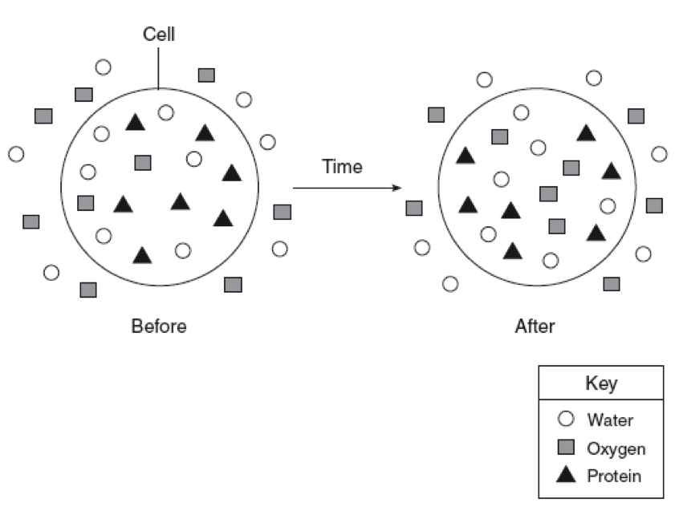

1. Label the cell membrane
   1. Top left =
   2. Bottom left =
   3. Top right =
   4. 2nd top on right (type of tails of phospholipid) =
   5. 3rd top on right (the circle of a phospholipid) =
   6. Bottom right =

