Protein synthesis!!!!!!!!!!!!!!!!!!!!!!!!!!!!!!!!!!!!
Read Q and answers below then answer questions 1-13 on your own paper.
- How do we know what proteins to make?
A: The directions for each protein is written in the DNA code.
A: The code is written in bases using A, T, C, G
- How do we make some proteins different than other people?
A: The order (sequence) of our DNA can be different (it will have directions for a different protein)
- What is a protein?
A: A protein is a chain of amino acids bonded together by peptide bonds. It is known as a polypeptide.

- How can proteins be different?
- Proteins act differently because of the order that different amino acids are hooked together.

- Where are all these proteins made?
A: At the ribosomes
- DNA can NOT leave the nucleus. How do the directions get to the ribosomes?
A: The CODE is Rewritten onto a molecule called mRNA. Its called Transcription.
- What’s the difference?
A: mRNA can leave the nucleus
A: mRNA is single stranded
A: mRNA contains U (uracil) instead of T (thymine)
- How does the chain of amino acids end up in the correct order?
A: Every 3 letters is “READ” and codes for an amino acid. This is called TRANSLATION.
- How do the amino acids get to the ribosomes?
A: A molecule called tRNA brings them. The t = transfer

- Which of these shows the correct order for the central dogma of molecular biology?
  - DNA to protein to RNA C. protein to DNA to RNA
RNA to DNA to protein D. DNA to RNA to protein
- What is the mRNA code complementary to the DNA code below?
AAC GCC AAA GGG
- How are the amino acids linked together during translation?
- What is the relationship between an organism’s DNA and protein produced?
- In the production of proteins, what is the function of messenger­RNA molecules?
- Proteins are composed of polypeptide chains. What are polypeptide chains composed of?
- In which part of the cell does the initial process of transcription take place?
- What is the complementary messenger­RNA sequence for the DNA sequence C­A­A­G­G­T?
- Which type of RNA delivers the genetic code to the ribosome?
- Which is the DNA complement of ATA GCG GCC?
- What two organelles are involved in protein synthesis?
- What is the function of transfer RNA?
- Which is a way that RNA differs from DNA?
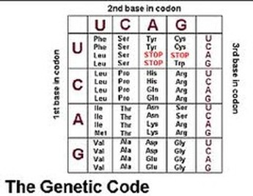
- Use the codon chart to find the amino acids coded for by the following mRNA
AUG CAU GUU UGA

