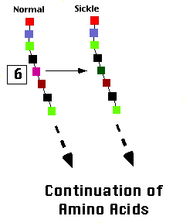
Figure 1. The chain of colored boxes represent the first eight amino acids in the beta chain of hemoglobin. The sixth position in the normal beta chain has glutamic acid, while sickle beta chain has valine. This is the sole difference between the two.
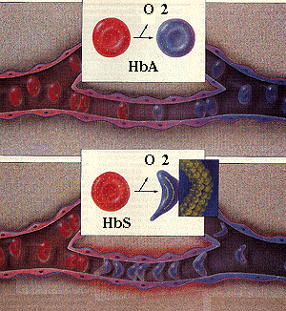
http://www.youtube.com/watch?v=PEDQoQuIhkg

Exit Ticket 10/17/12
- Explain the process of protein synthesis.
- Explain how to read a codon chart.

