MUTATIONS – what happens when something goes wrong.
Here is an example of some mutations in DNA…..
A
DNA - A T C G C T A G CAN YOU FIND THE MISTAKE
T A G G G A T C

Mistake A: one base is wrong………A G is paired with a G.
- This is called a POINT mutation because it is only 1 base wrong.
- What will be the outcome? Maybe nothing, maybe death…we will get more involved later

B
DNA - A T C C T A G CAN YOU FIND THE MISTAKE
T A G G G A T C

Mistake B: there is a missing base. Nothing is paired with G.
- This is called a deletion. Because a base has been deleted.
- This is also called a frame-shift mutation. Very BAD.

C
DNA - A T C G C T A G CAN YOU FIND THE MISTAKE
T A G T G A G A T C
Mistake C: There is too many bases.
- This is called an insertion. Because bases were added.
- This is also a frameshift mutation. Very BAD.

What makes some mistakes worse than others?

Here is why. Use the chart to write the chain of amino acids coded for.
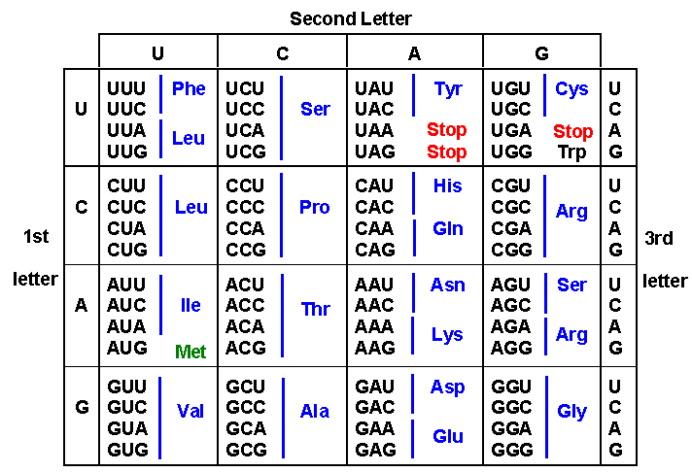

mRNA - AUG UUG CCG CCA GAU
- This has no mutations and the amino acid list below is a normal working protein
MET LEU PRO PRO ASP

Scenario ---point mutation

mRNA -- AUG UUG CCC CCA GAU
- Notice a C is there instead of G
- The new chain of amino acids will look like this
MET LEU PRO PRO ASP

Is there a difference? NO

Scenario ---- deletion

mRNA -- AUG UU CCG CCA GAU
- Notice the G in the second codon is missing
- NOW every 3 letters will be read…….like this
AUG UUC CGC CAG AU
- The chain will be……….
MET PHE ARG GLN
There is only one amino acid the same because it is “read” 3 letters at time so it changed everything. (insertions and deletions both cause this shift in the reading)

