Osmosis and Diffusion Packet
Draw arrows showing the direction of water movement. One the line, describe what will happen to the cell.

60% NaCl
40% H₂0

20% NaCl
90% H₂0

10% NaCl
90% H₂0

30% NaCl
70% H₂0

20% NaCl
80% H₂0

20% NaCl
80% H₂0

40% NaCl
___% H₂0

__% NaCl
70% H₂0

What will happen to the water levels?
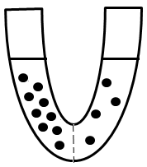
Active or Passive?
Diffusion Exocytosis
Osmosis Pinocytosis
Endocytosis Phagocytosis

Osmosis Problems:
Which way will the water move?

60%
H₂O
80%
H₂O
10%
H₂O
40% NaCl
5%
C₆H₁₂0₆
20%
C₆H₁₂0₆
80%
H₂O
10% NaCl
30% NaCl
20% NaCl
40%
H₂O
80%
H₂O
100%
H₂O
20%
H₂O
60%
H₂O
10% NaCl
Osmosis Problems:
- What is osmosis?
- Using an arrow, identify the direction the water molecules will travel due to osmosis.
66 molecules of H₂0
25 molecules of H₂0
16 molecules of H₂0
20 molecules of H₂0
45 molecules of H₂0
85 molecules of H₂0

- What property of water molecules allows osmosis to occur across a cell membrane?

- Do water molecules stop moving once they reach equilibrium? Explain your answer?

- Grocery stores spray their vegetables with water once every half-hour.
  - Identify the high concentration of water with an “H”
  - Identify the low concentration of water with an “L”
  - Draw an arrow showing where the water molecules will move.
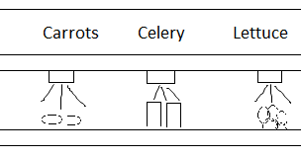
How do grocery stores use osmosis to their advantage to keep vegetables looking fresh and healthy?

Cell Processes
The cytoplasm of Elodea cells is composed of about 70 percent water molecules and 30 percent other kinds of molecules.
Read the three examples given below
- Elodea cells are put into a liquid that is 50 percent water.
- Elodea cells are put into a liquid that is 70 percent water.
- Elodea cells are put into a liquid that is 100 percent water.

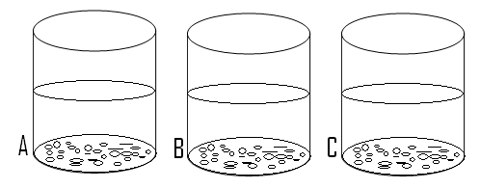

Study the predictions below and select the example that matches the prediction. In the space to the left, fill in the letter of the example you select.

- The percent of water molecules in the Elodea cells and in the liquid around them is about the same
- The percent of water molecules in the Elodea cells is larger than in the liquid around them
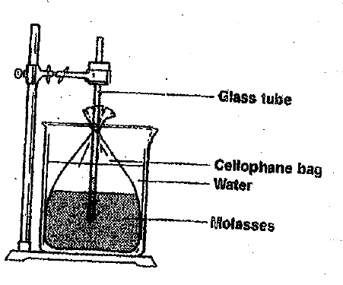
- The Elodea cells in the liquid will shrink
- The Elodea cells in the liquid will swell
- The Elodea cells will not change in size.

The diagram to the right shows a cellophane bag containing molasses. An open glass tube extends from the bag. The molasses comes up a short distance in the tube.

Use the diagram to answer the questions below.
- The movement of water molecules across the membrane is the result of
  - Osmosis b. Breathing c. The glass tube d. air pressure
- After the 24 hours, the size of the cellophane bag will probably be
  - Smaller. b. larger c. The same d. cannot tell
- After 24 hours, the cellophane bag will contain
  - Water only b. Molasses only c. both water and molasses d. neither
- After 24 hours, the cellophane bag will contain
  - Water only b. Molasses only c. both water and molasses d. neither
- After 24 hours, the level of liquid in the glass tube
  - Will be lower b. will be higher c. will be the same d. cannot tell

More Osmosis Problems
The direction in which water molecules move during osmosis depends on where the water molecules are more highly concentrated. Study the diagrams below.
  - Decide whether the solution in each beaker is hypotonic, isotonic, or hypertonic in relation to the solution inside the cellulose bag, then write your answer below each beaker.
  - Draw arrows to indicate the direction in which the water will move in each case.

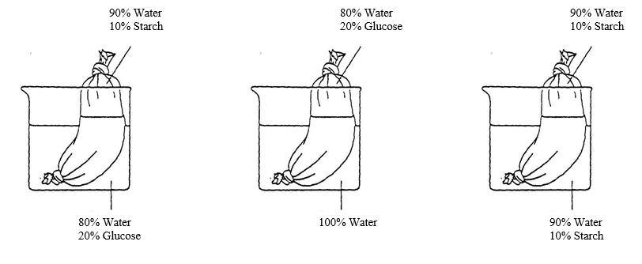
- In the U-tube diagram below, the membrane is permeable to solute A; however, it is NOT permeable to solute Z.
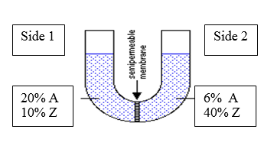
- What is going to happen to solute A (both direction and percentages)?

- What is going to happen to solute Z (both direction and percentages)?

- What is going to happen to the water levels, specifically?

For questions 1-3: A cell which is 98% water is placed into the following environments. Answer each question and indicate whether each solution is hypotonic, hypertonic, or isotonic.

1. A solution of 100% water: _____________________________
a. What is the direction of water movement?
b. Does the cell shrink, swell, or have no change in solution?
2. A solution of 10% sucrose: ____________________________
a. How much water is in the outside environment?
b. What is the direction of water movement?
c. Does the cell shrink, swell, or have no change in size?
3. A solution of 2% sucrose: _____________________________
a. How much water is in the outside environment?
b. What is the direction of water movement?
c. Does the cell shrink, swell, or have no change in size?

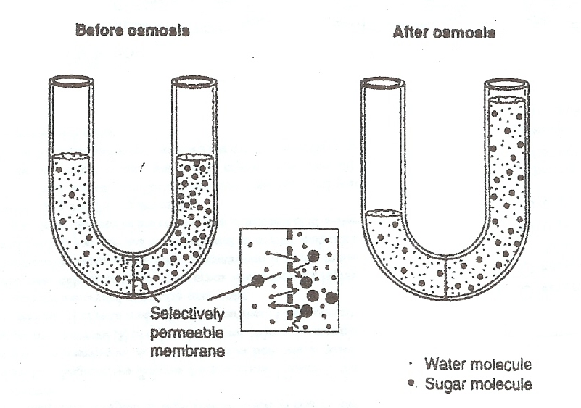
- Look at the U-tube. Why did the number of water molecules on each side of the membrane change after osmosis, whereas the number of sugar molecules stayed the same?

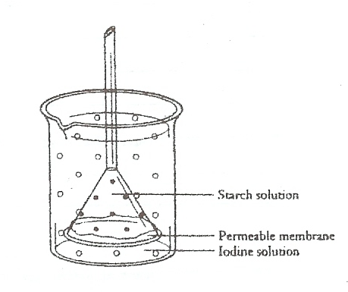
A selectively permeable membrane is stretched across a funnel filled with starch solution. The figure at the right shows the funnel inverted into a beaker containing an iodine solution. Starch molecules are too large to diffuse across the membrane. Iodine molecules are not. If Iodine reacts with starch, the starch turned blue-black. Suppose you observe the set-up after several hours.

- Does the iodine solution change color?
- Does the starch solution change color?
- Explain why each of the above occurred.

- Does the level of the liquid in the funnel rise, fall, or remain the same? Explain.

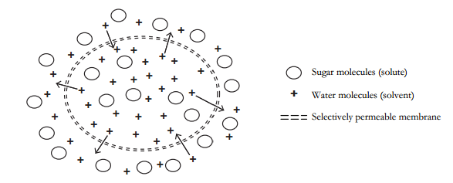
- A solution consists of a solute and a solvent mixed together. Consider the size of the sugar and water molecules. Which molecules in the diagram are able to move through the selectively permeable membrane?

- Complete the table below by counting the molecules in the picture.
 | Inside the cell | Outside the cell
Number of Sugar Molecules
Number of Water Molecules
Ratio of Water to Sugar

- Are more water molecules moving into or out of the cell? (Hint: look at the arrows!)

- Why isn’t the sugar molecule moving?

- Circle the correct word below to indicate the change in the concentration of the sugar solution on each side of the membrane as water moves.
  - The solution inside the cell will become (more/less) concentrated with the net movement of water.
  - The solution outside the cell will become (more/less) concentrated with the net movement of water.

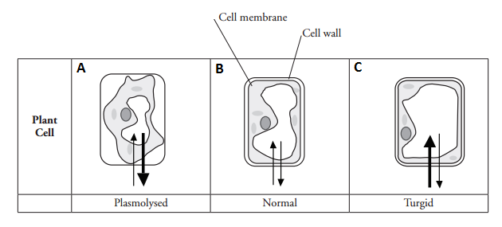
- The arrows in the picture show a movement of water into and out of the cells. What does the thickness of the arrow show?

- For each of the following, identify which picture would best describe the situation:
  - A plant cell in a hypertonic environment
  - A plant cell in a isotonic environment
  - A plant cell in a hypotonic environment
  - A freshwater plant in saltwater
  - Lettuce being sprayed with distilled water at the grocery store
  - A saltwater plant growing next to the beach

