OSMOSIS
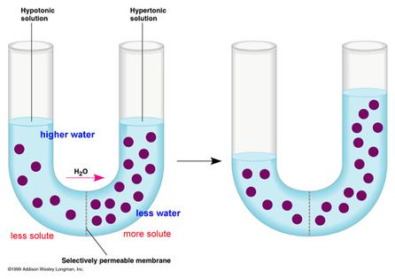
Water moves from an area of HIGHER concentration to an area of a LOWER concentration until EQUILIBRIUM is met.
DIFFUSION
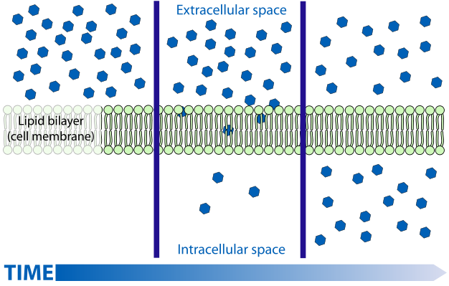
- Record the number of sodium molecules (blue) on each side of the cell membrane as time passes.
DIFFUSION is the movement of molecules from an area of HIGH concentration to an area of LOW concentration.
DIFFUSION and OSMOSIS are examples of PASSIVE TRANSPORT because they use NO ENERGY

