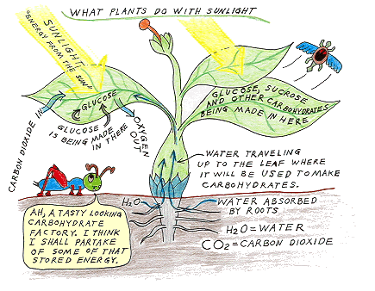**Photosynthesis**

Not all of the light from the Sun makes it to the surface of the Earth. Even the light that does make it here is reflected and spread out. The little light that does make it here is enough for the plants of the world to survive and go through the process of photosynthesis. Light is actually energy, electromagnetic energy to be exact. When that energy gets to a green plant, all sorts of reactions can take place to store energy in the form of sugar molecules.

[Photosynthesis](http://www.emc.maricopa.edu/faculty/farabee/BIOBK/BioBookglossPQ.html#photosynthesis) is the process by which green plants, some bacteria, and some protistans use the energy from sunlight to produce sugar, which [cellular respiration](http://www.emc.maricopa.edu/faculty/farabee/BIOBK/BioBookglossC.html#cellular respiration) converts into [ATP](http://www.emc.maricopa.edu/faculty/farabee/BIOBK/BioBookglossA.html#adenosine triphosphate (ATP)), the "fuel" used by all living things. The conversion of unusable sunlight energy into usable chemical energy, is associated with the actions of the green pigment [chlorophyll](http://www.emc.maricopa.edu/faculty/farabee/BIOBK/BioBookglossC.html#chlorophyll). Most of the time, the photosynthetic process uses water and releases the oxygen that we absolutely must have to stay alive. Oh yes, we need the food as well!

We can write the overall reaction of this process as:

**6H2O + 6CO2 ----------> C6H12O6+ 6O2**

Most of us don't speak chemicalese, so the above chemical equation translates as:

**six molecules of water** plus **six molecules of carbon dioxide** produce **one molecule of sugar** plus **six molecules of oxygen**

## http://www.emc.maricopa.edu/faculty/farabee/BIOBK/leafstru.gifLeaves and Leaf Structure

Plants are the only photosynthetic organisms to have [leaves](http://www.emc.maricopa.edu/faculty/farabee/BIOBK/BioBookglossL.html#leaves) (and not all plants have leaves). A leaf may be viewed as a solar collector crammed full of photosynthetic cells.

The raw materials of photosynthesis, water and carbon dioxide, enter the cells of the leaf, and the products of photosynthesis, sugar and oxygen, leave the leaf.

Within the cells of plants are organelles called chloroplasts. Within this cell organelle is the chlorophyll that captures the light from the Sun.

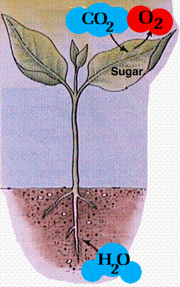**Molecules of Photosynthesis**

Chlorophyll is the magic compound that can grab that sunlight and start the whole process. Chlorophyll is found in the chloroplast of green plant leaves. Other molecules involved in photosynthesis are water (H2O), carbon dioxide (CO2), oxygen (O2) and glucose (C6H12O6). Carbon dioxide and water combine with light to create oxygen and glucose. That glucose is used in various forms by every creature on the planet. Animal cells require oxygen to survive.

**Light and Dark Reactions**

The whole process does not happen all at one time. The process of photosynthesis is divided into two main parts. The first part is called the light dependent reaction. This reaction happens when the light energy is captured and pushed into a chemical called ATP. The second part of the process happens when the ATP is used to make glucose. This second part is called the light independent reaction.

**Draw a diagram to illustrate the process of photosynthesis:**

**Write the equation that shows the process of photosynthesis:**