For each picture: explain the process, identify, label, give function and write a multiple choice question using the diagram

the correct equation for cellular respiration is

* 1. **6O2 + C6H12O6  🡪 6CO2 + 6H2O + Energy**

Photosynthesis equation is……..

**6CO2 + 6H2O +light 🡪 6O2 + C6H12O6**

A

 B

C





D E

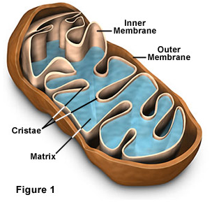

F G

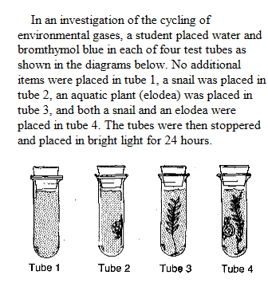

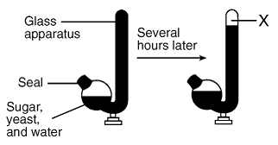H I

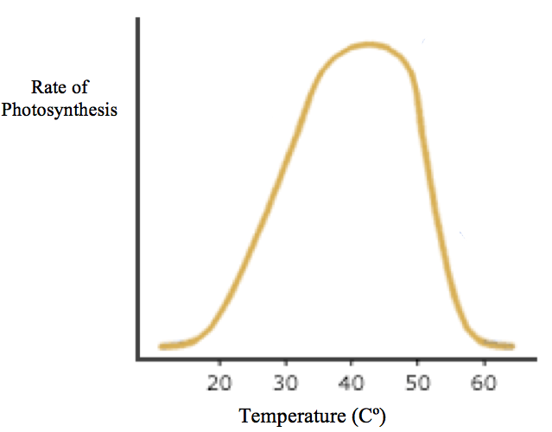

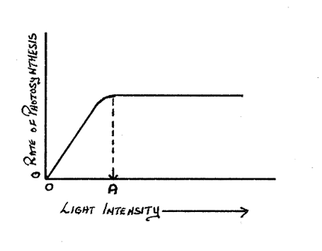J