Use to plant page on website to see better views.
A B
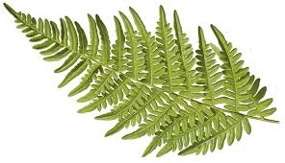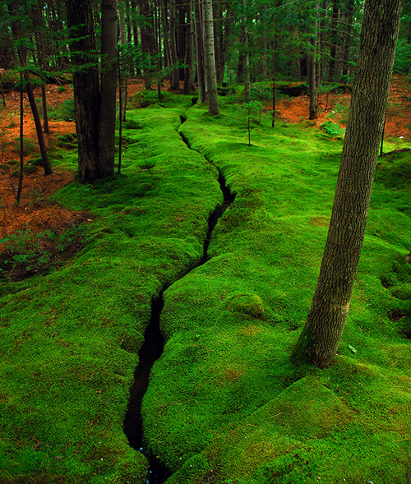
C D.
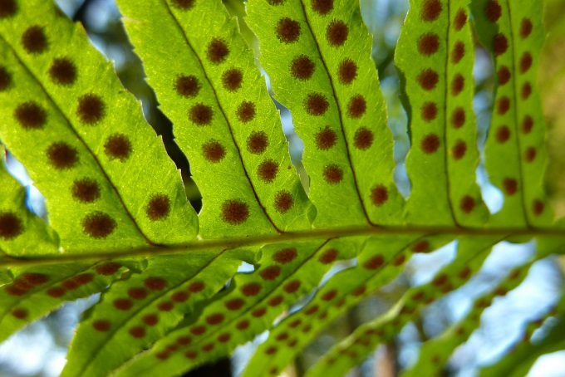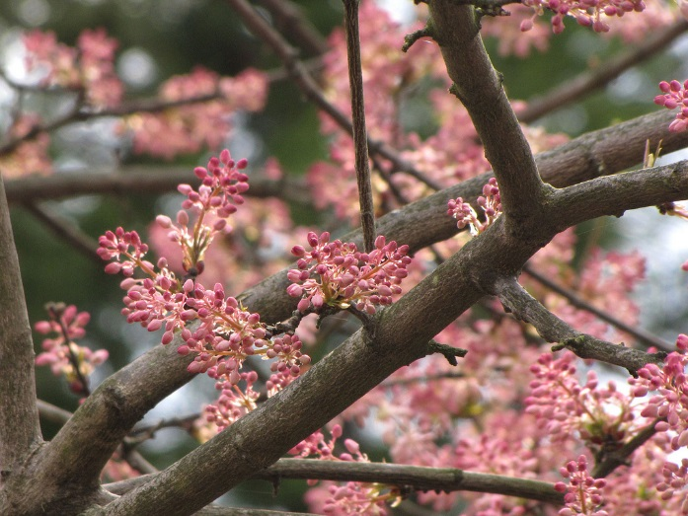
E
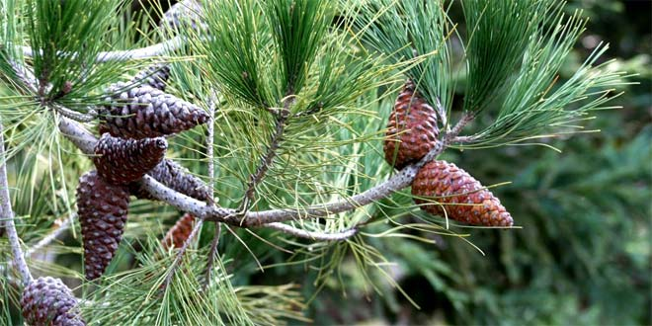

F G
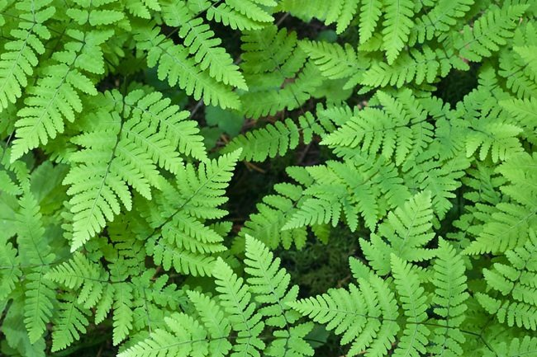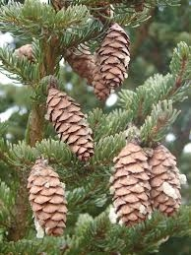
H I.
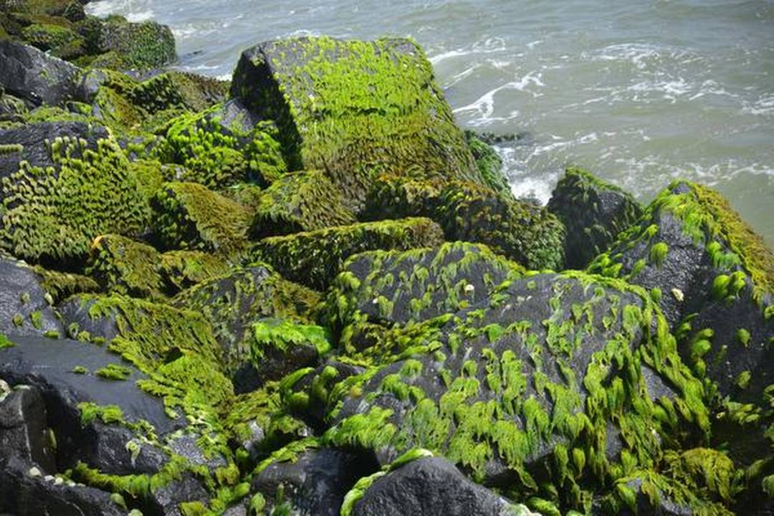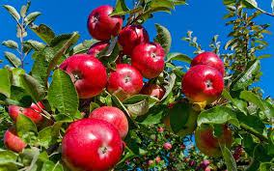
J K
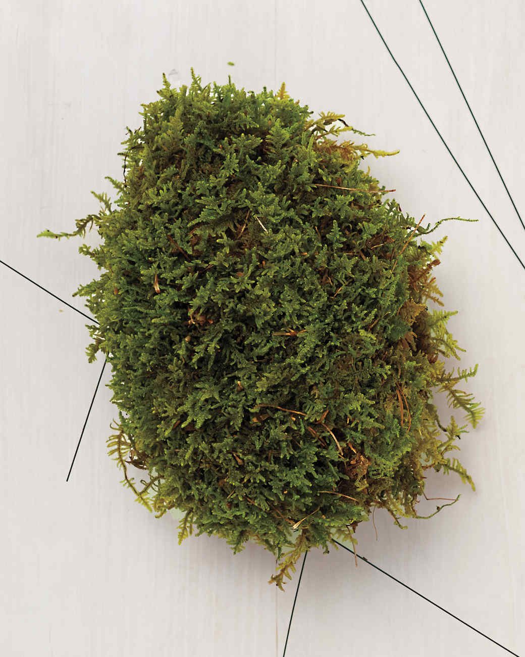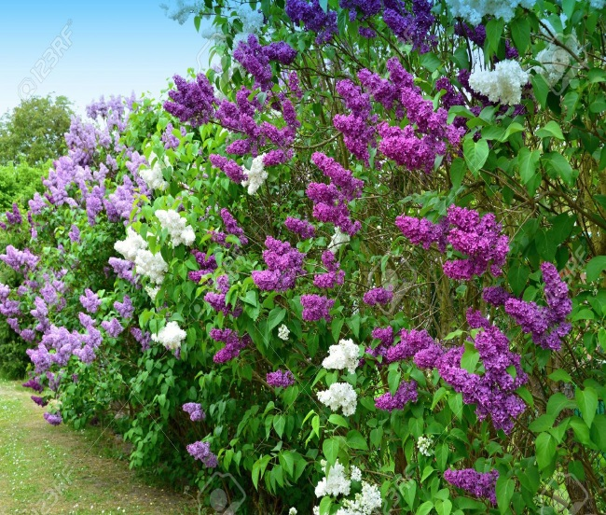
Characteristic | Letter of picture |  | Characteristic | Letters
Bryophyta |  |  | Pine cones are seeds
Moss |  |  | Most successful
Pterophyta |  |  | Have fronds
Fern |  |  | Must grow near water
Gymnosperm |  |  | Have sori
Pine trees |  |  | Lose leaves
Angiosperms |  |  | Naked seeds
Flowering Plants |  |  | First plant to evolve
Have fruit |  |  | Vascular, seedless
Have needles |  |  | Non-vascular, seedless
Have pollen |  |  | Attract insects
No vascular system |  |  | Evergreens
Have Spores |  |  | Conifers
Have seeds |  |  | No leaves stems or roots

Characteristic | Letter of picture |  | Characteristic | Letters
Bryophyta |  |  | Pine cones are seeds
Moss |  |  | Most successful
Pterophyta |  |  | Have fronds
Fern |  |  | Must grow near water
Gymnosperm |  |  | Have sori
Pine trees |  |  | Lose leaves
Angiosperms |  |  | Naked seeds
Flowering Plants |  |  | First plant to evolve
Have fruit |  |  | Vascular, seedless
Have needles |  |  | Non-vascular, seedless
Have pollen |  |  | Attract insects
No vascular system |  |  | Evergreens
Have Spores |  |  | Conifers
Have seeds |  |  | No leaves stems or roots

