Answer questions 1-16 on your own paper
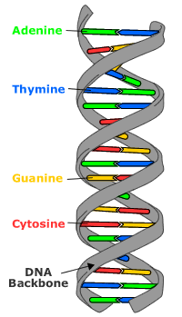
Use the diagram of DNA to the right to answer the questions
- This is a shape called a double helix.
- How many strands (gray part in diagram) are there in a DNA molecule?
- Name the 4 bases in DNA
- How are the bases paired together? What goes with what?

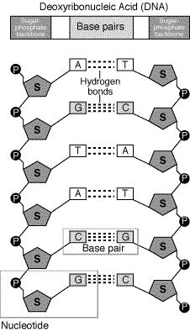
- What is the whole name of DNA?
- How are the base pairs held together?
- What 2 molecules make up the backbone of DNA?
- What 3 things make up a nucleotide?

DNA replication: The steps are shown below (read the explanations and answer the questions).
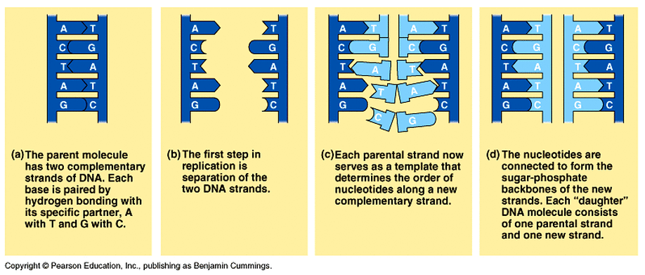
- Notice the original 2 strands are dark blue
- Notice the enzyme helicase unwinds and separates the strands
- Notice the original DNA is the template for the new (light blue) nucleotides to be put down by DNA polymerase
- Notice the 2 DNA molecules are now half original and half new

- What does the enzyme helicase do?
- Look at the diagram, why does DNA need to be unwound and separated?
- What does DNA polymerase do?
- Replication is called semi-conservative because it becomes half new and half old strands. If the 2 molecules in letter (d) were to replicate again making 4 DNA molecules (and the new strands were green) what would the colors of the 4 new ones be?
- What goes with cytosine?
- What goes with guanine?
- What goes with thymine?
- What goes with adenine?

