Using Recombinant DNA to change an organism (Example making bacteria make human insulin)
STEP 1: Find the DNA that contains the gene for making insulin (IT IS YELLOW see below)
STEP 2: Insert the human gene into another piece of extra DNA (called a plasmid its GREEN see below)

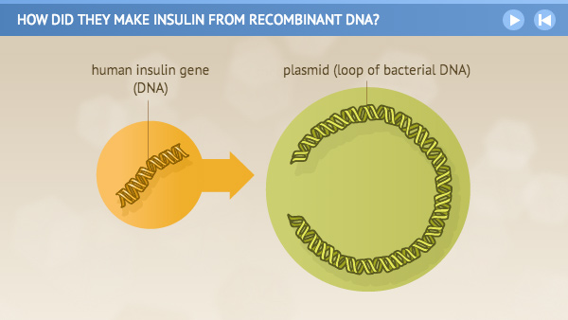
NOTICE: Below you can see the yellow gene for insulin in the green plasmid.
STEP 3: Put the plasmid in bacteria. The HUMAN GENE will make the bacteria make insulin for us.
STEP 4: The bacteria is now a TRANSGENIC ORGANISM because it has human DNA in it.
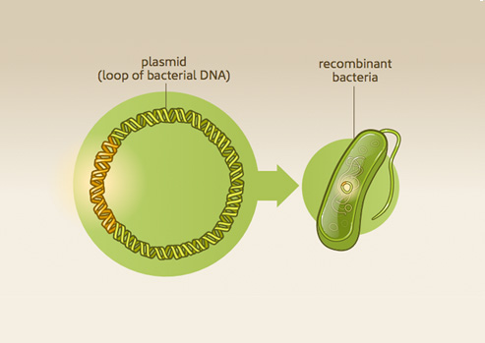
How else can we use this TECHNOLOGY?
- On plants: make them RESISTANT to disease * add vitamins to them or other nutrients
- Make them RESISTANT to insects * make them bigger and juicier
- Make them RESISTANT to drought * Make them last longer

Questions:
- What is the technology called that combines one organism gene to another organisms?

- What is an organism called that has “foreign” DNA in it?

- Can we use this technology on plants to make them better?

- Name 6 ways we can use this technology on plants to ensure food for everyone.

SHOULD WE USE THIS TECHNOLOGY ON THE PLANTS WE EAT?????????????????????????????????
Pros Cons (POSSIBLE)
More food Can cause increase in allergies
Less chemicals used Gene can be spread to weeds by cross pollination
Longer lasting food Reduce usefulness to antibiotics to people eating them
Easier to grow Reduce the genetic variation of plants (less different kinds)
Reduce competition w/weeds May kill beneficial insects

Write a 4 sentence paragraph convincing me not to grow/buy GMO’s.

Using the link below. Answer the questions and perform the virtual lab.
https://learn.genetics.utah.edu/content/labs/gel/
- DNA collected is cut into fragments. What cuts DNA?
- What process sorts DNA by size?
- What else can be separated by gel electrophoresis?
- What is the “filter” that sorts the DNA?
- Where do we put the DNA?
- What makes the DNA move?
- Does the DNA travel to the positive or the negative?
- What charge does DNA have?
- Which types of DNA fragments move faster and further?
- What is done in order to see the DNA?
- Draw the completed DNA fingerprint after the performing the virtual lab.
Answer the questions about stem cells using the link to the article below.
https://www.yourgenome.org/facts/what-is-a-stem-cell
- What is a stem cell?
- What are the 2 properties of stem cells that allow them to have their functions?
- What are the 3 types of stem cells
- Which one would be controversial?
- Why are stem cells useful (2 uses)
- What can stem cell research be useful for? Name 1.
- Name 2 genetic conditions stem cell therapy can help?
WHO DID IT? AND WHO’S THE DADDY?
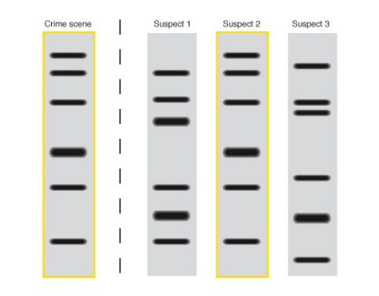
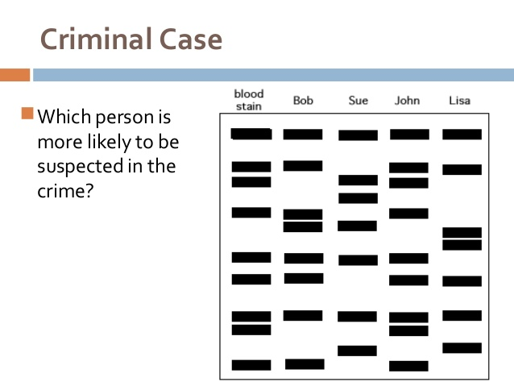
k
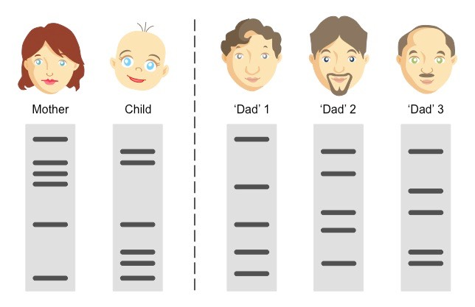
Explain the parents of both children?
