Structure of DNA
- DNA is made up of subunits called nucleotides
  - Below shows what a DNA nucleotide is made up of.
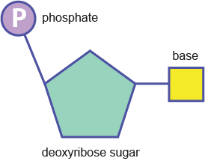

- There are 4 different bases that can be in DNA
  - A = adenine
  - C = cytosine
  - T = thymine
  - G = guanine
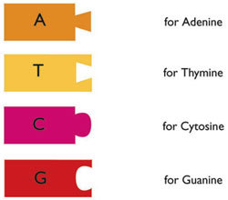
Can you tell which bases go to together?
Hint: look at the shapes

- Shape of DNA
The shape is called a double helix (a twisted ladder)
- The backbone is made up of Phospahate and sugar
- The bases make up the rungs of the ladder (the part you step on)

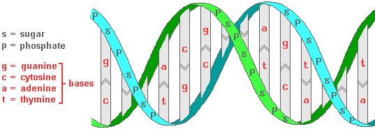

- What holds the bases together?
- Hydrogen bonds
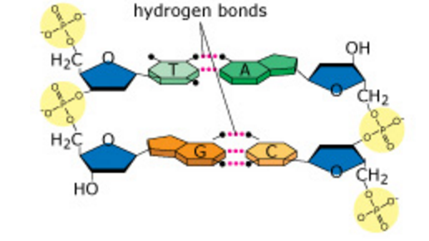
- What bases go to together and what are they called.
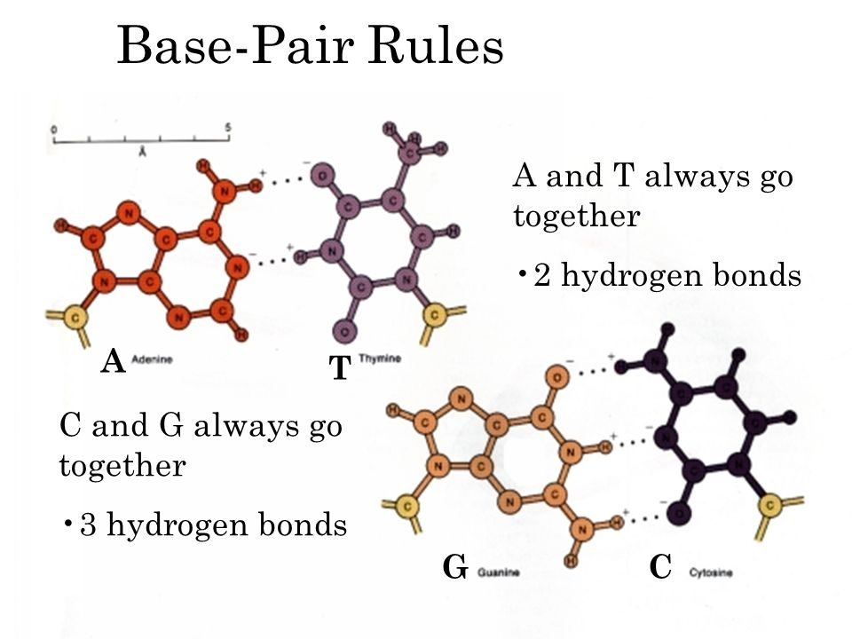
A PAIRS T
C PAIRS G
- The order of the bases is called the BASE SEQUENCE.
The base sequence of this unwound DNA is………………….
C T G C A G T

What is a COMPLIMENTARY base sequence……
- The complimentary sequence is the bases that would connect to the original sequence.
- For the above base sequence the complimentary sequence would be..
  - G A C G T C A
Practice: What is the complimentary DNA sequence for the following sequence of DNA
A C T C G G T A C G A T T T G A C

