Here’s what you need to know:
CELL TRANSPORT:
- Passive Transport – movement of substances across the plasma membrane without the use of the cell’s energy (with the concentration gradient)
- DIFFUSION – movement of substances across the plasma membrane from an area of high concentration to an area of low concentration
- OSMOSIS – diffusion of water across the plasma membrane from areas of high concentration to areas of lower concentration
- FACILITATED TRANSPORT – a carrier molecule embedded in the plasma membrane transports a substance across the plasma membrane following the high-to-low concentration gradient
- Active Transport – movement of substances across the plasma membrane that requires the use of the cell’s energy and carrier molecules; substances are moving from an area of low concentration to an area of higher concentration (against the concentration gradient)
- ENDOCYTOSIS – large particles are brought into the cell
- EXOCYTOSIS – large particles leave the cell
- HOMEOSTASIS – internal equilibrium; the plasma membrane regulates what enters and leaves the cell; a selectively permeable membrane only allows certain substances to pass through
- Effect of Concentration on a Cell
1. HYPOTONIC – water moves in; cell bursts
2. HYPERTONIC – water moves out; cell shrivels
3. ISOTONIC – no net movement; cell maintains equilibrium
Independent Practice

Observe the diagram below
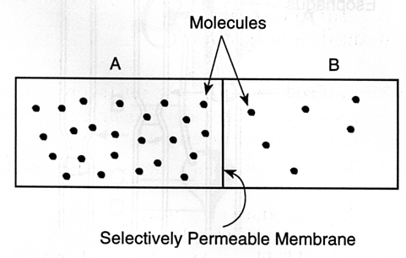
- If the membrane in the diagram is permeable to the molecules in the diagram, in what direction will the molecules move?

- A cell membrane is considered to be selectively permeable. What is meant by the term selectively permeable?

- Compare and contrast diffusion and osmosis.

- What happens when an animal cell is placed in fresh water?

- The cell membrane is a phospholipid bilayer that contains some proteins. Describe how this structure allows the membrane to be semi-permeable.

- Victims who nearly drowned in pool or lake water generally have more lung infections afterward than those who nearly drowned in ocean water. From your knowledge of animal cells and different types of solutions, give an explanation for this situation.

- A cell has a concentration of 0.8% glucose and 60% water. The surrounding environment has a concentration of 25% glucose and 70% water. The cell membrane is permeable to both glucose and water.
Draw a picture of the cell and indicate in which direction glucose and water will flow over time.

- A beaker is filled with water. A bag containing solution A is placed in a beaker. It is known that the molecules of solution A cannot move out of the bag into the water. This indicates that the backs membrane is
  - not permeable to solution A
  - made of lipids and proteins
  - semi -- permeable to solution A
  - completely permeable to solution A

- The rate at which molecules diffuse is dependent upon the concentration of the solution, temperature and pressure. A student sits in the front of the room and opens a bottle of perfume. At which temperature below will the students in the back of the room smell the perfume most quickly?
- 0°C B. 10°C C. 25°C D. 30°C

- Kidney dialysis is the artificial filtering a person's blood to remove wastes when the kidneys have failed. What type of membrane would be used to filter the waste from blood?
- Impermeable B. permeable C. osmotic D. selectively permeable
- Plasma membranes are term selectively permeable because they permit
  - certain molecules to enter a cell and exclude others
  - only water molecules to enter and leave the cell
  - only substances in solution to pass through
  - small molecules to pass through while larger molecules are excluded

- A cell in the lung of the human had a small supply of oxygen and a large amount of carbon dioxide. Air containing large amounts of oxygen in small amounts of carbon dioxide entered the lung. How would the cell be affected?
  - Oxygen would leave the cell; carbon dioxide would enter.
  - Oxygen would enter the cell; carbon dioxide would leave
  - Both oxygen and carbon dioxide would enter the cell by active transport.
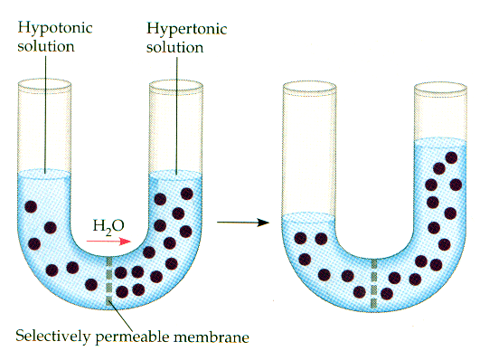
  - Bothoxygen and carbon dioxide would lead the cell by passive transport.

- What are examples of solute?

- Why did the water levels change?

- What is a concentration gradient?

- Define selectively permeable membrane.

