Transcription – the making of RNA by using DNA
Where – in the nucleus
What does it – RNA Polymerase
Difference – There are no T’s in RNA they are replaced by U
Purpose – transcription copies the code for protein onto RNA so it can leave the nucleus

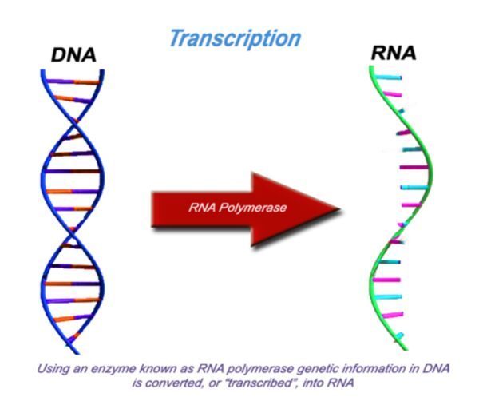
Practice problems
DNA = A T C C G T A G C T C C A T T A A
- WHAT WILL THE SEQUENCE OF AN RNA MOLECULE MADE FOR THE DNA MOLECULE ABOVE BE?
RNA =

