1. What is the molecule? What macromolecule does it belong to? What shape is it?

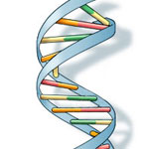

B. What is the molecule? What is the subunit (hint there are 4 of them shown) What sre the 3 parts to the subunit?



1. Name the molecule? What is it made up of? What macromolecule does it belong to?

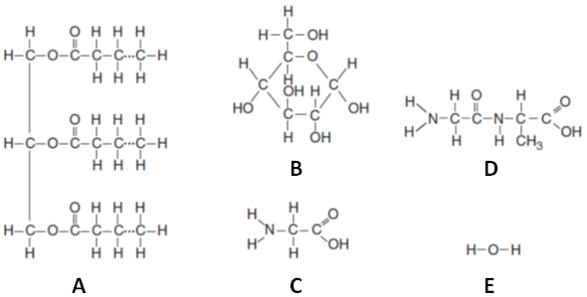

1. Name the molecule. What is the formula? What macromolecule is it a subunit for?



E. What is the molecule? What is it a subunit for? The sequence of these makes up an enzymes _____.



1. Name the molecule. Name the bond that holds holds them together.



1. Name the molecule. What is the formula? Is it organic or inorganic?
2. Which is the enzyme? What is the substrate? Is it a decomposition or synthesis reaction?



1. Label all the letters. Is it a decomposition or synthesis reaction?

