Angiosperm Reproduction: The Flower
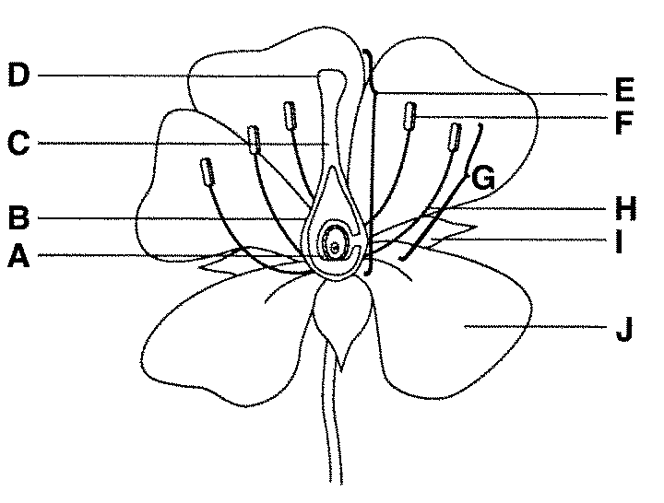
Flower Structure and Reproduction
Flowers are the plant’s reproductive structures. Angiosperms are types of plants that bear fruits and flowers. Flowers are usually both male and female, and are brightly colored to attract insects to help carry pollen used for sexual reproduction. Not all flowers are colorful. These flowers usually use the wind for pollination. Gymnosperms use cones to reproduce and don’t produce flowers.
- ______________________contains egg, becomes the seed after pollination
- ______________________contains ovule and eggs, becomes fruit after pollination
- ______________________connects stigma to ovary so sperm can swim to the eggs
- ______________________top of the pistil, pollen attaches itself here and release the sperm
- ______________________female part that is made up of (A, B, C, D)
- _____________________produce the pollen
- _____________________the male part that is made up of (F and H)
- _____________________holds the anther for easier access to pollen
- _____________________leaf like structure that protect flower before it blooms
- _____________________usually brightly colored to attract insects to their nectar (which leads to pollination)
- _____________________contains sperm and keeps the sperm from drying out during transfer
Plant Reproduction
Sexual reproduction in plants occurs when the ____________________________________is transferred to the stigma. Plants can fertilize themselves: called self-______________________. Self-pollination occurs when the pollen from the anther fertilizes the eggs on the SAME flower. Cross-_________________________________ occurs when the pollen is transferred to the stigma of an entirely DIFFERENT plant. Nearly all plants undergo sexual reproduction.
- Allows for variation

Asexual reproduction- the prefix of asexual reproduction means “without”, so asexual reproduction means reproduction without sex. An example would be taking a ______________________from a plant and growing a new plant or the runner off of a strawberry plant to produce a new plant.
- No variation
- Allows us to keep characteristics we want in our crops, flowers, and other plants

When the eggs are fertilized, they will develop into _________________. The petals of the flower fall off leaving only the ______________________behind, which will develop into a _____________________. There are many kinds of fruits, including apples, arranges, and peaches. A fruit is any structure that encloses and protects a seed, so fruits are also “helicopters”, acorns, and bean pods. When you eat a fruit, you are actually eating the ________________________ of a flower.

Pollination: the transfer of ________________ to the ________________.

Occurs by ________________ and water in gymnosperms and angiosperms
Occurs by ________________ only in Angiosperms because the flower is __________________________ and smells good. Most contain __________________________ a sugar that the insects want and while feeding they get pollen on them and transfer it to the next flower.

