Blood Typing/ Multiple Alleles

A number of human traits are the result of more than 2 types of alleles. Such traits are said to have multiple alleles for that trait.
Blood type is an example of a common multiple allele trait. There are 3 different alleles for blood type, (A, B, & O). A is dominant to O. B is also dominant to O. A and B are both codominant.
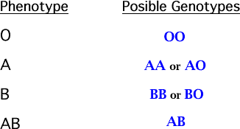

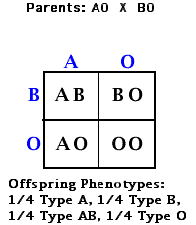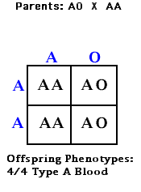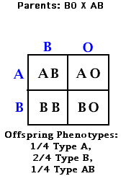
------------------ ------------------

Table Two: Distribution and Characteristics of Human Blood Factors
Blood Type | Distribution in USA (%) | Antigen on Red Blood Cell | Antibody in Serum Plasma | Will Clot with Blood From These Donors | Can Receive From | Can Give to:
O | 48 | None | Anti-A, Anti-B | A, B, AB | O | All
A | 42 | A | Anti-B | B, AB | A & O | A & AB
B | 7 | B | Anti-A | A, AB | B & O | B & AB
AB | 2 | A & B | None | None | All | AB

Type O Blood: Universal Donor as it contains no A or B antigens, so the receivers' blood will not clot when given the O blood.
Type AB Blood: Universal Receiver, as it contains no Anti-A or Anti-B antibodies in its plasma. It can receive all blood types.
Antigen: Protein on the surface of the blood cell. (Allele A makes A antigen. Allele B makes B antigen. Allele O makes no antigens.)
Antibody: Protein in plasma that reacts with specific antigens that enter the blood (usually something that isn't supposed to be there!). (Ex.: Anti-A is an antibody that recognizes A-antigen, binds to it (lock & key), then causes clumping together or clotting of similar A-antigens.)

