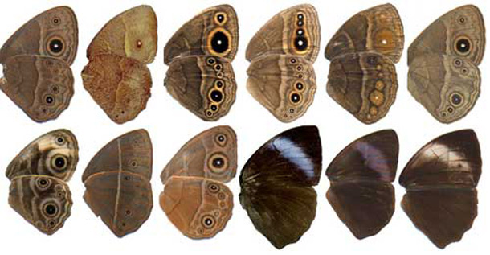
A.What is it showing? What process does it come from?
B. What is it showing? What process does it occur during? What does it promote?
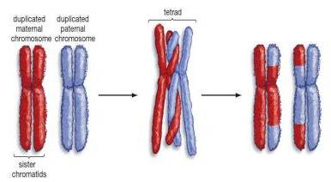
C. What process is shown? What type of reproduction?
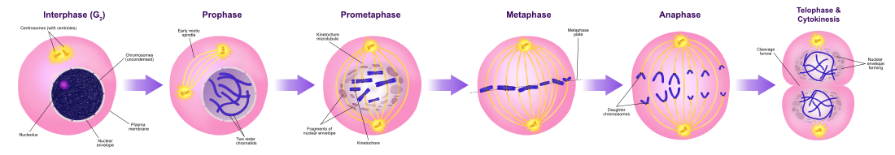
D. Define each. What process forms each? E. Label each cell. What process is shown? Label each
N or 2n
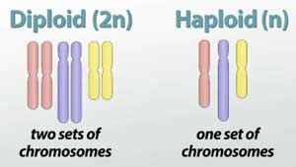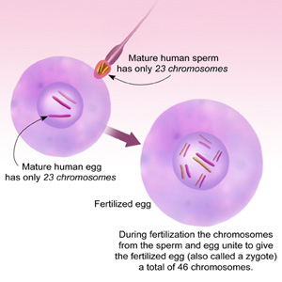

F. What process is shown? What 4 cells are produced? What is wrong with the cells produced? Why?
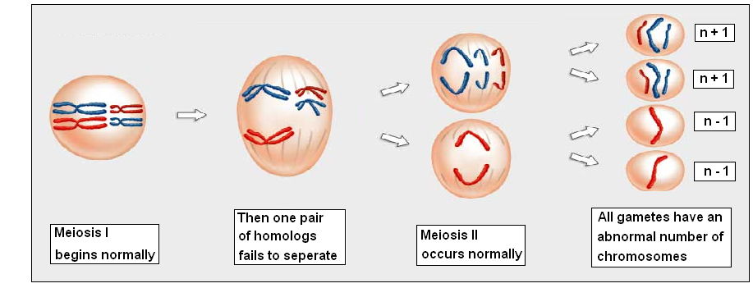
G. What type of reproduction? What process? H. Type of reproduction? Organism?
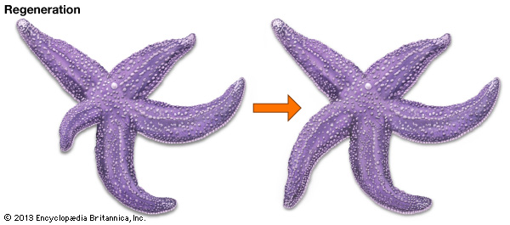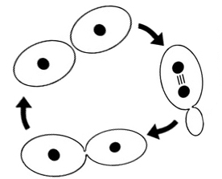
- Type of reproduction? Organism?
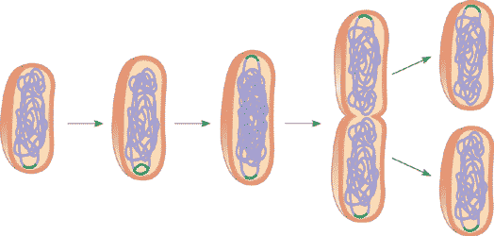

J. Type of reproduction? Organisms? K. Name both cells? Label haploid or diploid
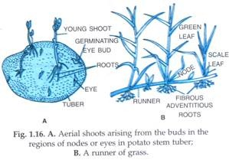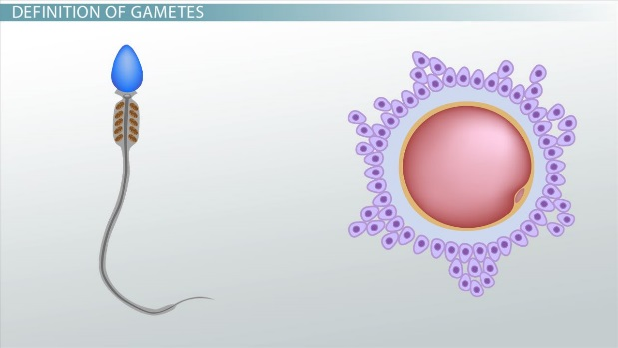

L. Name the cells? What process is shown? M. Phase? What is happening?
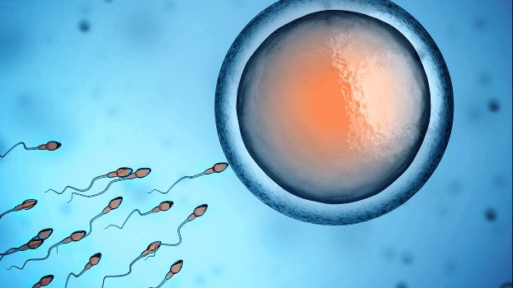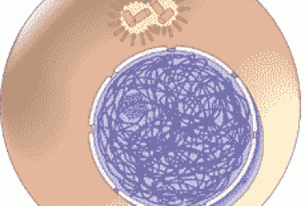
N. Phase? What is happening? O. Phase? What is happening?
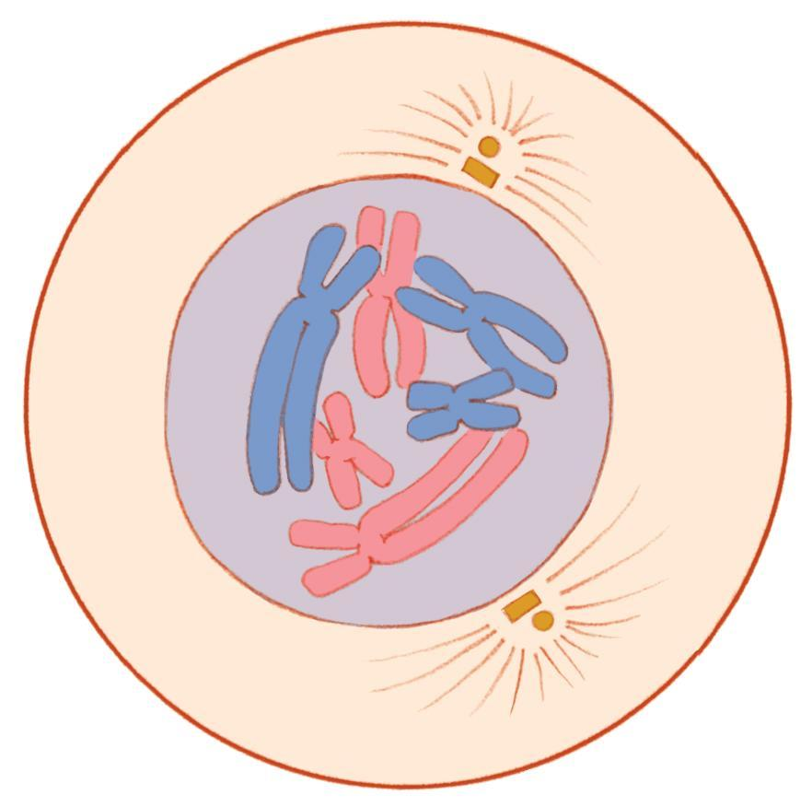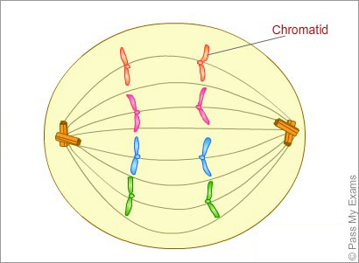

P. Phase? What is happening? Q. Phase? What is happening?
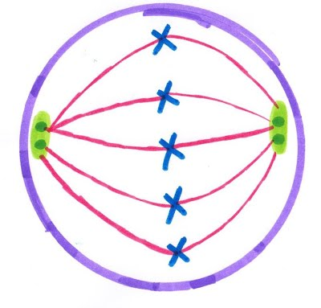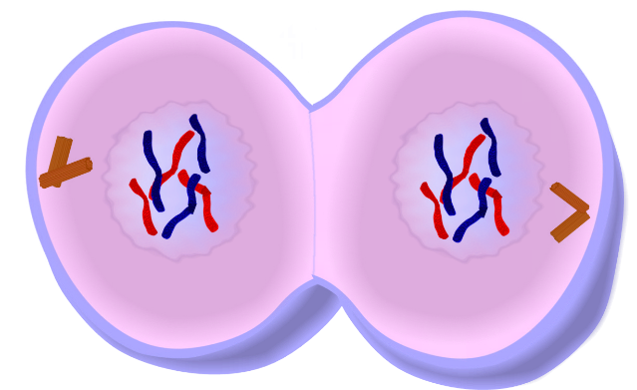
R What type of cells are these? How many cells are in anaphase?
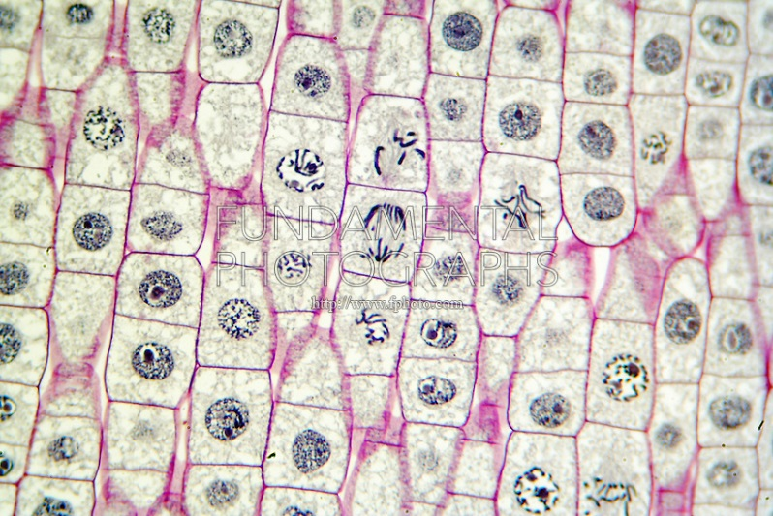
S. What is happening in the metaphase cell? T. Name phase?
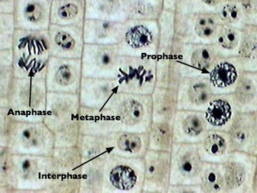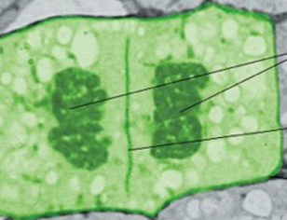

U What phase is the cell being pointed at in?

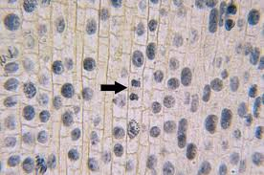

V. Name the type of reproduction and the organism.
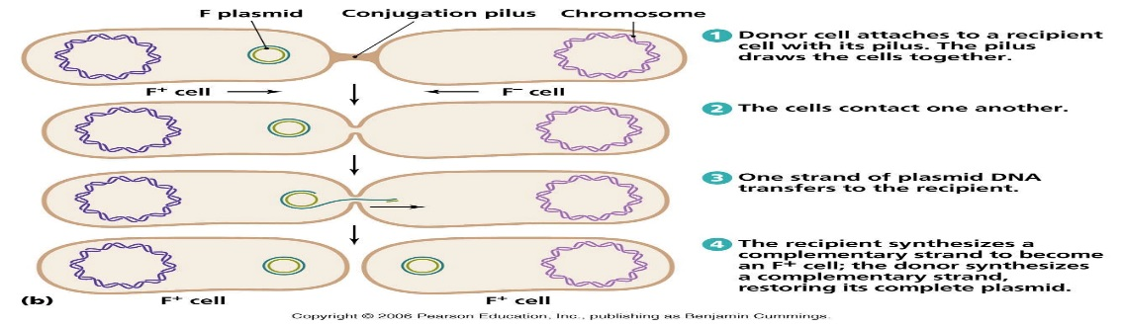
W. What phase are cells labelled 6 – 10 in?
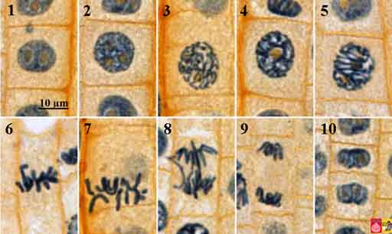

X. Type of reproduction and name the organism.
