Part 1 – Cell History
To do well on this section of the exam, you should know:
- What are the three parts of cell theory?

Scientist Name | Discovery or Contribution
Robert Hooke

Anton von Leewenhoek

Matthias Schleiden

Theodor Schwann

Rudolph Virchow

Part 2 – Cell Organelles
To do well on this section of the exam, you should be able to identify organelles by name AND by sight from a picture or model. Make sure you observe each of the models around the room so that you know what to expect.
Cell Organelle | Function
Plasma Membrane | 7.
Nucleus | 8.
Mitochondria | 9.
Chloroplast | 10.
Cell Wall | 11.
Vacuole | 12.
Centriole | 13.
Endoplasmic Reticulum | 14.
Golgi Body | 15.
Ribosomes | 16.
Cytoplasm | 17.

18. Why are the membranes within organelles highly folded?

Part 3 – Cell Types
To do well on this part of the exam, you should be know the similarities and differences between prokaryotes and eukaryotes; plant cells and animal cells.
19. Create a Venn diagram comparing prokaryotes and eukaryotes that has AT LEAST two entries in each section.

20. Create a Venn diagram comparing plant cells and animal cells that has AT LEAST two entries in each section.

Part 4 – Basic Cell Transport
To do well on this section of the exam, you should be able to distinguish between active and passive transport and identify the specific types of transport used in different situations.
Situation | Active or Passive?
Diffusion | 21.
Osmosis | 22.
Endocytosis | 23.
Movement of Na across a membrane against a concentration gradient | 24.
Movement of water across a membrane from a high to low concentration | 25.
Pumping K ions from a low to a high concentration. | 26.

27. What happens to the rate of molecule movement if facilitated diffusion is used?

28. Explain why the rate of diffusion is different between simple and facilitated diffusion.

29. What component of the plasma membrane is used in facilitated diffusion?

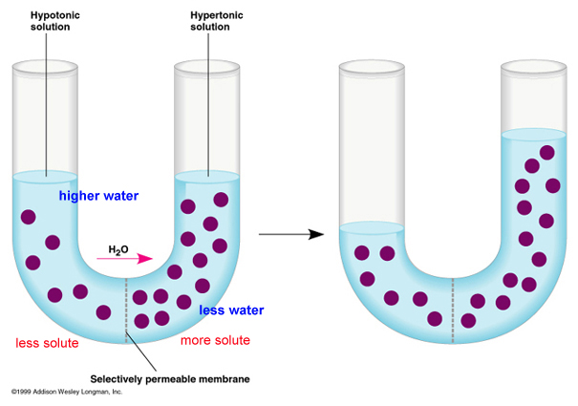

30. Why are the dark molecules not moving?

31. What is moving AND how can you tell?

32. What specific type of cellular transport is this?

33. Does this type of transport require energy?

34. What specifically do cells use as energy?

Part 5 – Plasma Membrane
To do well, you should know what each part of the plasma membrane does and how this contributes to the overall function of the organelle.
35. Sketch the fluid mosaic model of the plasma membrane.

36. What function do the proteins play in the plasma membrane?

37. What function do the carbohydrates play in the plasma membrane?

38. What life process does the plasma membrane most directly affect?

