CELL MEMBRANE aka PLASMA MEMBRANE

FUNCTION:

* It surrounds the cell separating the inside from the outside
* It maintains the cell’s homeostasis
* It controls cell transport of materials into and out of the cell

STRUCTURE

* Made up of a phospholipid bi-layer (2 layers of phospholipids)
* Parts of the membrane:
  + Phospholipid
  + Proteins
  + Carbohydrates

PHOSPHOLIPID DIAGRAM (BELOW) : Notice how the two layers are tail to tail

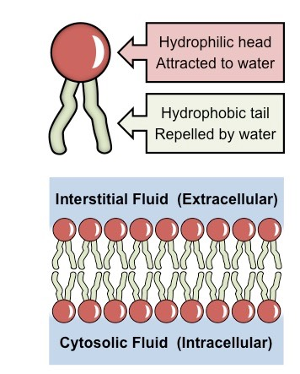



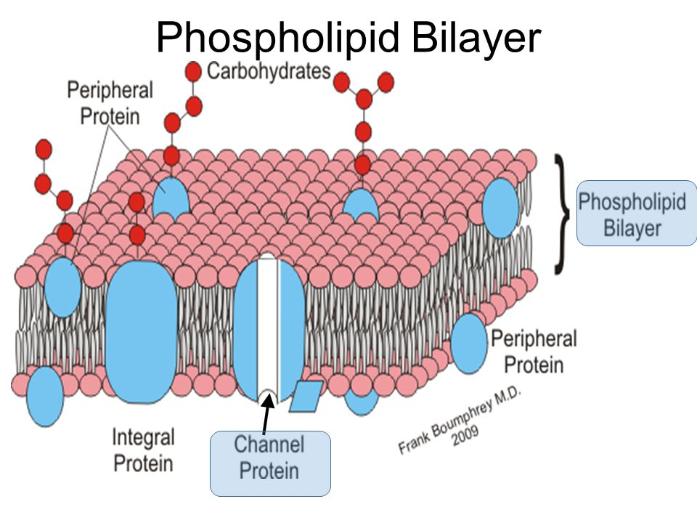

Function of Proteins

1. Channel or Transport Proteins : allow molecules to pass through them from High to Low in or out of the cell.
2. Protein Pumps: Actively pump molecules from low to high in or out of the cell using energy
3. Marker Proteins: ID the cell using the carbohydrate chain as the identifier.
4. Receptor proteins: receive information for the cell

TRANSPORT ACROSS THE MEMBRANE

PASSIVE TRANSPORT: USES NO ENERGY

* MOLECULES MOVE HIGH TO LOW
* DOWN THE CONCENTRATION GRADIENT

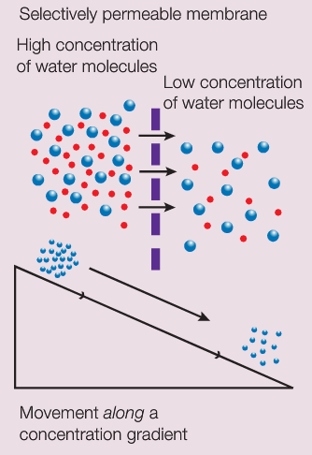

TYPES OF PASSIVE TRANSPORT

1. **Diffusion:** Movement of molecules form an area of HIGH concentration to an area of LOW concentration.

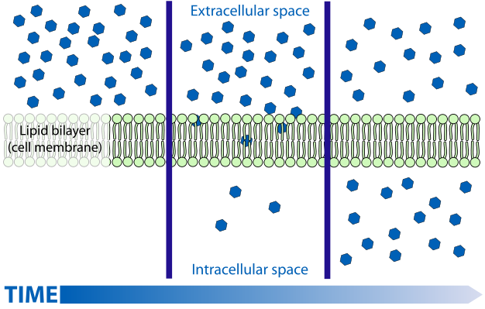

The **BLUE** molecules moved over time from out of the cell into the cell. From HI to LO.

1. OSMOSIS: The diffusion of WATER from Hi to Lo.

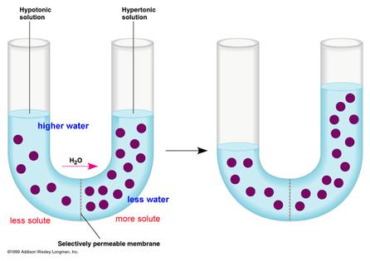

1. FACILITATED DIFFUSION: When sugar moves into cells from HI to LO but with help from a protein

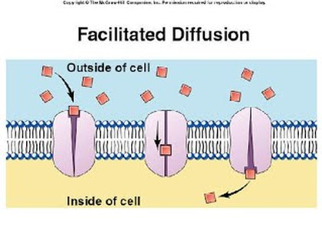

OSMOSIS EXAMPLES:

water moved out of the cell causing the membrane to shrink

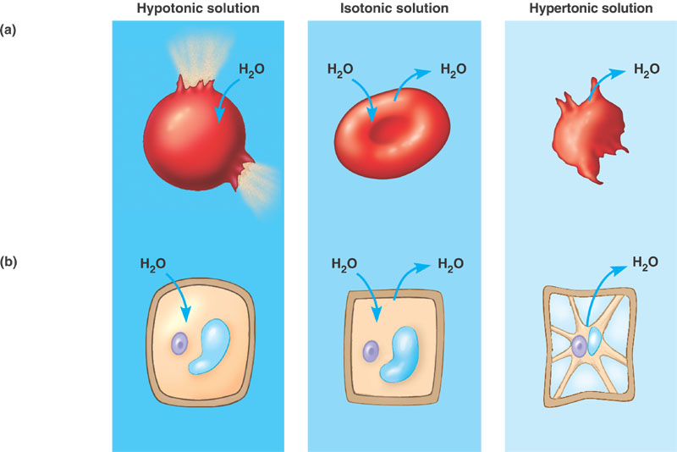

1. Water moves in – bursts
2. Equilibrium
3. Water moves out – shrinks

ACTIVE TRANSPORT – MOLECULES ARE PUMPED FROM LO TO HI USING ENERGY

