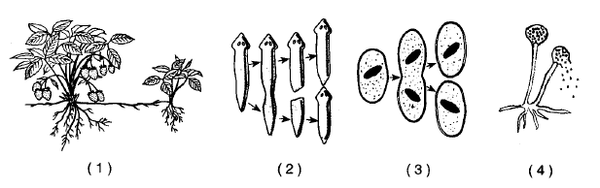

Identify each type of asexual reproduction illustrated above.

What is asexual reproduction?

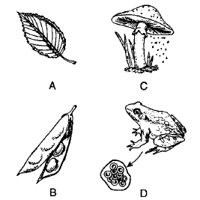
eggs

Which of these is not a reproductive structure?

By which reproductive method were the pea seeds formed?

What are the reproductive cells shown in the diagram for organism C?

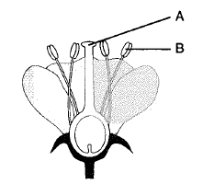
C
Identify structures A and B.

Which type of reproduction is the flower involved?

Which sex cells are produced by structure A? C?

What is the transfer of pollen to egg called?

What is the result of this process?

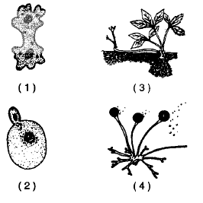

Identify the forms of asexual reproduction above.

Identify the organisms too.

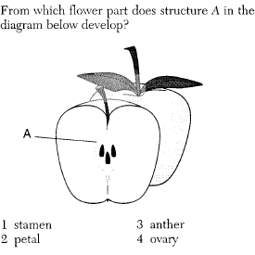

What is the purpose of the “fruit”?

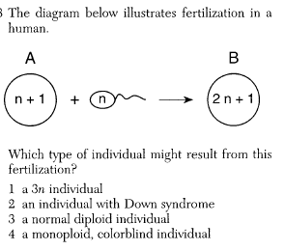

What caused the extra chromosome in the egg cell?

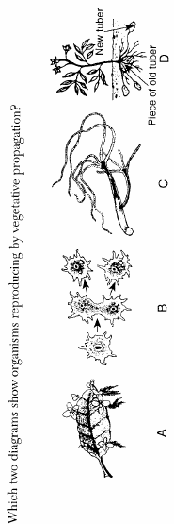

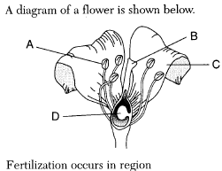

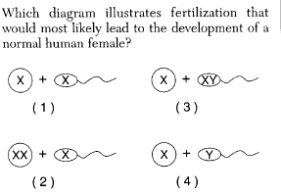

Which gamete determines the sex of the human child?

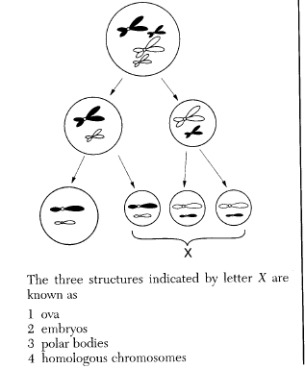

Which type of cell division is the illustration showing?

How do you know?

How would you describe the chromosome number of each newly formed cell?

Why is there only one viable egg produced?

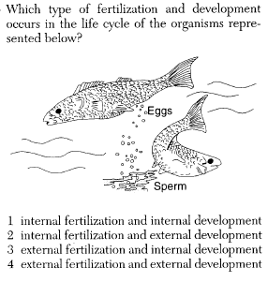

How will the offspring of these fish look compared to their parents?

Why?

What is meant by variation?

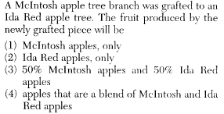



Is this method sexual or asexual reproduction?

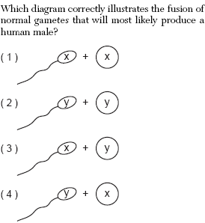

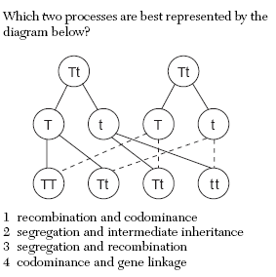

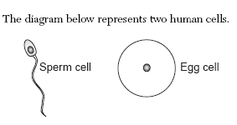

How were these cells produced? Which cell division process?

What is the normal chromosome number of these two cells? Why is that important?

If the sperm unites with the egg, what is this process called?

The newly formed cell from that process is called a ___________. It will have two sets of chromosomes, so it’s chromosome number is called ___________ . The actual number of chromosomes is________.

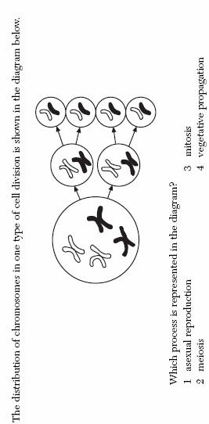

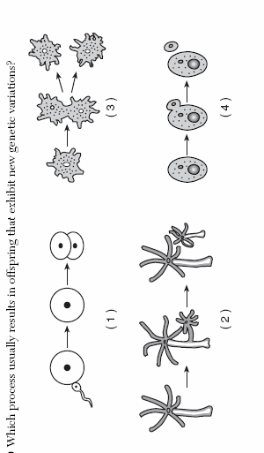

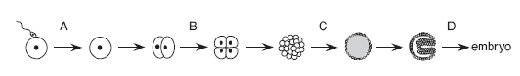

Circle the place where fertilization takes place.

Label and name the two gametes. Which cell division process made the gametes?

Identify the zygote.

In the illustration above, identify where mitosis is occurring.

What is the result of mitosis in this overall process, growth or reproduction?

