- Which factor would have the greatest effect on the flow of energy into an ecosystem?
- a large decrease in the amount of sunlight available B. a large increase in the number of carnivores C. a small increase in the number of decomposers D. a small decrease in the amount of minerals
- Young rabbits that eat grass are sometimes eaten by raccoons, which also eat seeds and berries. Bacteria help to decompose the excretions of the raccoon. Which statement about these nutritional relationships is accurate?
A. Rabbits are secondary consumers. B. Raccoons eat only producers. C. Raccoons are both primary and secondary consumers. D. Bacteria are scavengers.
3. If birds eat insects that feed on corn, which pyramid level in the diagram would insects occupy?
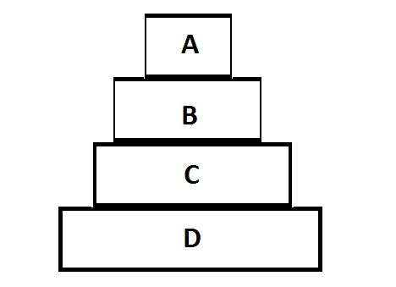
- If level D has 10,000 kcal of energy, how much would level B have?
- 9,980 B. 980 C. 100 D. 1000

- Circle the group organisms that would have the MOST total energy
