ENZYMES
- Are PROTEINS which are made from chains of AMINO ACIDS
- Enzymes function as catalysts
- Catalysts speed up chemical reactions
- Enzymes speed up chemical reactions by lowering the ACTIVATION ENERGY
- ACTIVATION ENERGY is the energy needed to START a reaction
- Enzymes work on SPECIFIC substrates that fit into the enzyme’s ACTIVE SITE
- SUBSTRATES are the molecule that an ENZYME works on
- Enzymes can only work on one substrate because of their SHAPE
- Once an Enzyme starts a reaction it releases the substrate and is ready for another one.
- Enzymes only work on one type of molecule, they are ______________________.
- The amount of energy needed to begin a reaction is ____________________.
- Catalysts ______________ up chemical reactions.
- The molecule an enzyme works on is called a ____________________.
- Can an enzyme be re-used?
- Enzymes are a type of the macromolecule called _________________ which are made up of chains of __________________________.
- The place a substrate binds to the enzyme is called the __________________.
- Enzymes speed up chemical reactions by __________________ the amount of energy needed to start them.

Figure 1
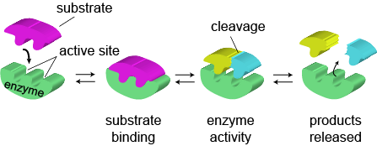

Figure 2
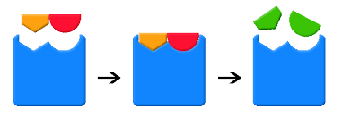
A B C
Use Figure 1 to help you label the following in Figure 2
- Figure 2, part A, the blue substance is an ________________________________________
- In part A, the orange and red substance is the ___________________________________
- Part B is called the _______________________________________________________
- In Part C, the green substances are the ________________________________________
- In Part C, the green substances are released, this allows the blue substance to
- Both Figures 1 and 2 represent the __________ and _________ model for enzyme function.

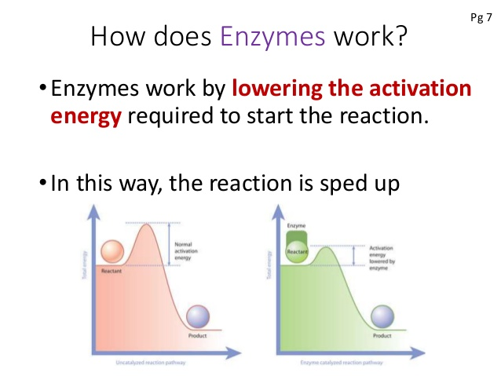
- Which ball (orange or green) has a larger hill to get up before it can roll down?
- Which ball will need less energy to get up the first hill before it can roll down?
- Which ball will be able to roll down sooner?
- The “HILL” represents the ___________________________ energy.
- Which color diagram represents a reaction with an enzyme?

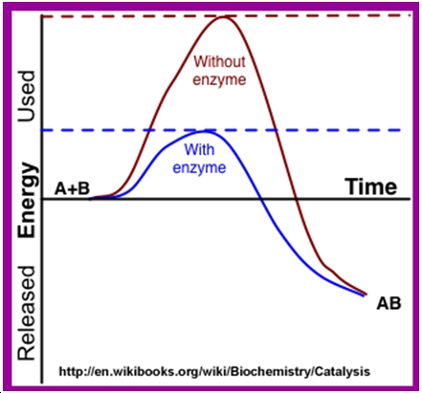

- Which reaction USES more energy (red or blue)?
- Which reaction has an enzyme?
- What did the enzyme do to the energy needed or used?
- The energy used to start the reaction is the _____________________ energy

How can ENZYME function be affected?

ENZYMES LIKE SPECIFIC CONDITIONS in order to work at their OPTIMUM speed.

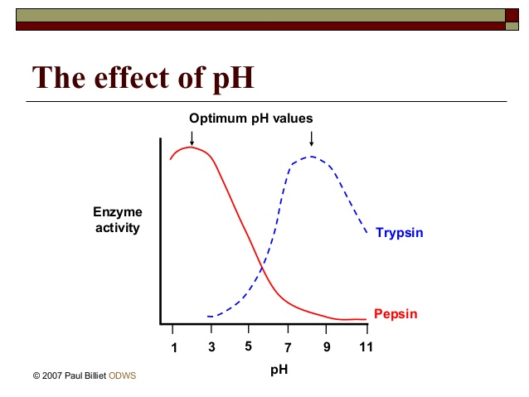

- Pepsin is an enzyme that works best at what pH?
- Does pepsin work better in an acid or a base?
- What pH does the enzyme called trypsin work the fastest?
- When pepsin is at it optimum pH, what can you tell about trypsin?
- Which of these enzymes would you most likely find in your stomach?
- Are all enzymes at their optimum at the same pH?

How does temperature affect ENZYMES?

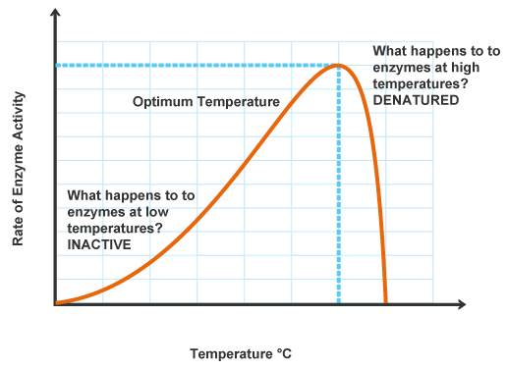
0 10 20 30 40 50 60 70 degrees
30. According to the graph at 0⁰, how well do enzymes work?
31. As the temperature increases from 0 to 40, what happens to the rate of the reaction?
32. At what temperature does this enzyme work its best?
33. What happens when the temperature exceeds the optimum conditions for the enzyme?
34. Do all enzymes work best at the same temperature?

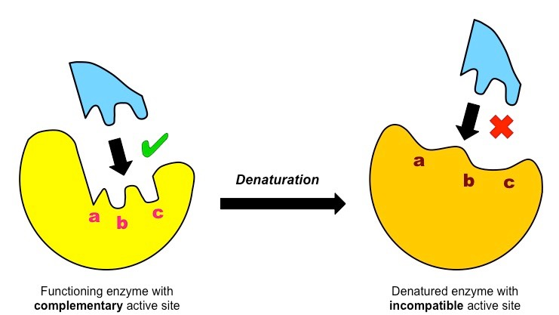

35. Why can the bright yellow enzyme work on the substrate?
36. Why won’t the denatured enzyme work on the substrate?
37. Denaturing did what to the enzyme?
38. What can cause an enzyme to be denatured?

Can the amount of substarte available speed up the enzyme?

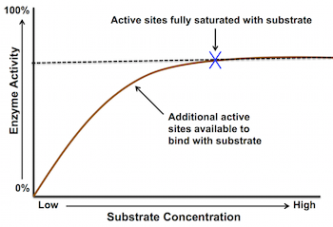

39. The more SUBSTRATE available the ____________________ enzyme activity.
40. Saturated means full. If the active sites are saturated with substrate, that means every active site has a ________________________ bound to it.
41. If every enzyme is working, can the activity get any higher?
42. Substrate concentration (the amount of substrate) will ____________________ enzyme activity but only to a certain point.

