Evolution Review:
A.
- What process produces oxygen?
- What happened to the oxygen levels 2500 MYA?
- What caused this increase in oxygen?
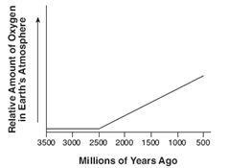
B.
- Homo means?
- Homologous structures are structures that are the _____________.
- The letter A in the diagram represents?
- These homologous structures indicate that the organisms all have a?
- What type of evidence of evolution is this?
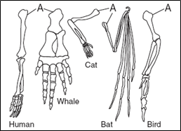
C.
1. What species is most closely related to the unknown species?
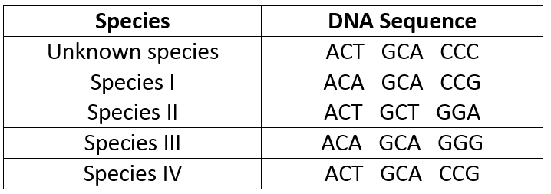
D.
1. What is the law of superposition?
2. Which fossil is the oldest?
3. Which fossil is the youngest?

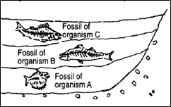
E.
1. In the original population of rabbits, what was the most successful fur color?
2. !0 years later, how did the population change?
3. What type of natural selection occurred?
4. What happened to the white rabbits?
5. Explain what might have happened?

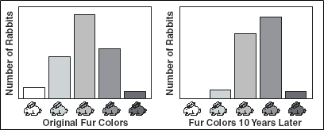
F.
1. What does the term “variety” mean?
2. What happened to variety B by the 55th generation?
3. Why may this have occurred?
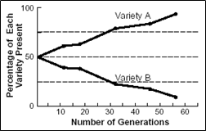
G.
1. The graph shows that average size beaks have decreased over time, what type of natural selection has occurred?

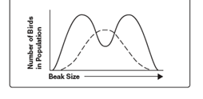
H.
1. Which species has the most variation?
2. Which species has the least variation?
3. If changes occur in the environment, which will most likely be able to survive?
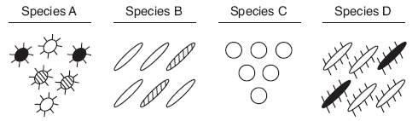
I
- What features of the birds show adaptations?
- What could be the cause of these adaptations?
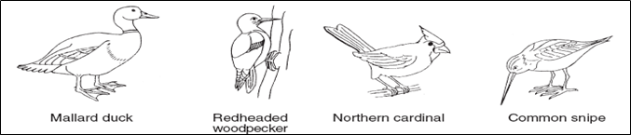

J.
1. What does a pesticide do?
2. Which insect was able to survive the spray better?
3. This demonstrates a ______________________ to pesticide.
4. This is an example of?

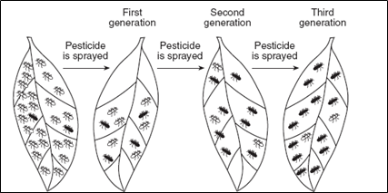
K.
1. What feature shows an adaptation in the birds?
2. Who studied these birds and came up with the theory of natural selection?
3. What environmental factor most likely caused this evolution?
4. What is the name of this type of evolution?

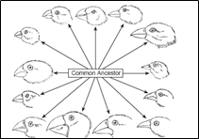
L.
1. What adaptations does this insect have?
2. What might its color allow him to do better?
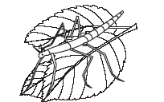

M.
1. What environmental factor increases the success of bigger beaks?
2. What is this an example of?
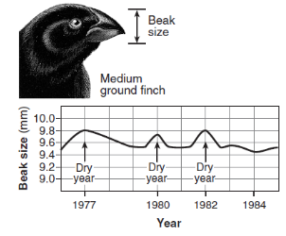
N.
1. Immediately after a pesticide was sprayed on the 10,000 mosquitoes, what happened to the population size?
2. Why did the spraying later each month not affect the mosquitoes?

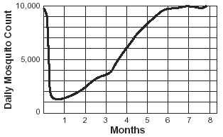

O.
1. Which 2 organisms have the most similar DNA?
2. Which 2 organisms have the most recent common ancestor?
3. Which 2 organisms are most closely related?
4. Name all of the categories or taxa that organism B and C share.
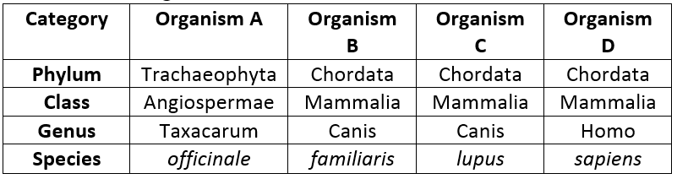

P.
1. Name the 3 domains
2. Explain how evolutionary pathways work?
