Facilitated Diffusion: passive transport from high to low with help from a transport protein.

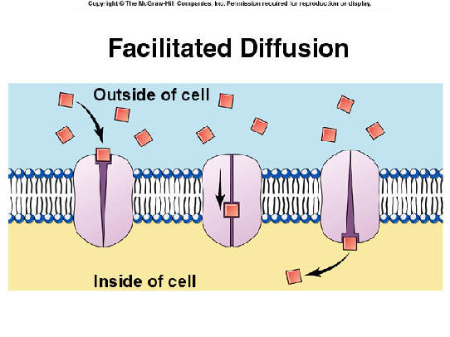 Example: Glucose – it is TOO big to go thru the membrane

ACTIVE TRANSPORT: Use ATP (energy) to move molecules from LOW to HIGH. Up or against the concentration gradient

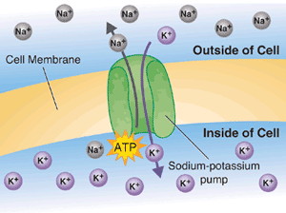

Other types of Active Transport

1. Exocytosis: removing solid materials from the cell using ATP.
2. Endocytosis: getting solid materials into the cell

