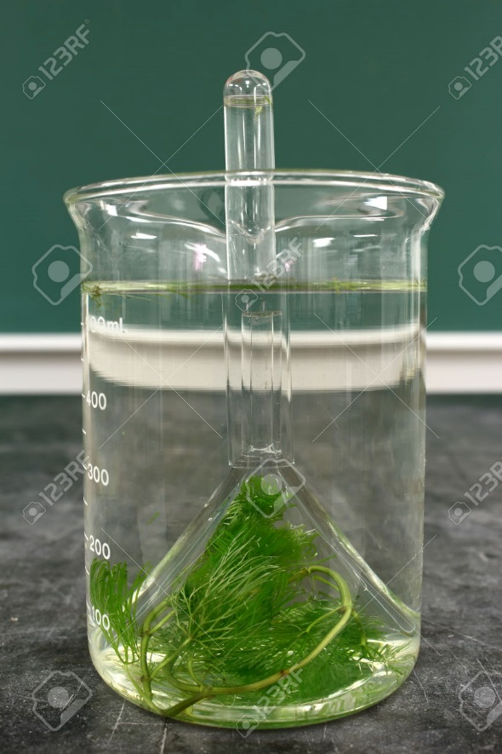
- What can you observe in the set-up to know the plant is doing photosynthesis?
_________________________________
- Name 4 things (variables) that can be changed to affect the rate at which the plant is performing photosynthesis.

- What will indicate a faster rate of photosynthesis (what can we measure?)

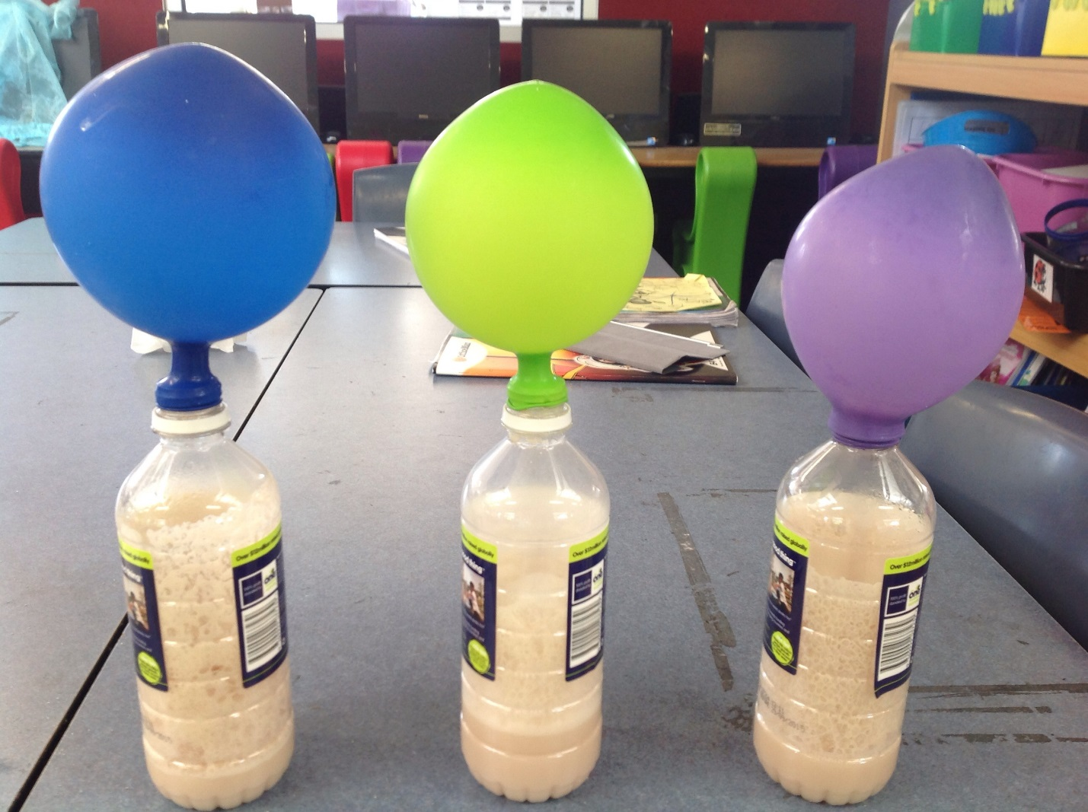

- What single celled organism is in the bottles?

- What has filled up the balloon?

- What process is occurring in the bottle?

- Is this aerobic or anaerobic respiration?

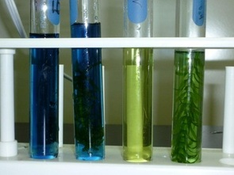

Bromothymol blue indicates carbon dioxide.
Blue = no CO2
Green/yellow = CO2 is present
- Why is the 2nd test tube blue?

- What will happen to the 2nd test tube if a snail is put in it?

