*Fill in EVERYTHING! Macromolecule Chart Organic molecules are based on CARBON.
Elements: C = Carbon, H = hydrogen, N= nitrogen, O= oxygen, P= phosphorus, S= sulfur
Macromolecules,  Biomolecules,  Organic Compunds | Elements  CHNOPS | Subunits A-K-A  Monomers A-K-A  Building Blocks | Functions:  Why are they important? |  | Examples:  Where can we find them? |  | Test(s)  (Indicators)
Carbohydrates  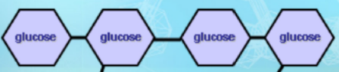 | _________  Ex:  C₆H₁₂O₆  Glucose (simple sugar) | ___________________  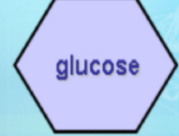 |  | ____________________________________ |  | ________________ -plant  ________________ - animal  _______________________– glucose, fructose, sucrose  _______________________– plant cell walls | ________________: turns purple/blue/black in starch  ____________________: turns red, orange or green in simple sugars such as glucose
Lipids: Fats  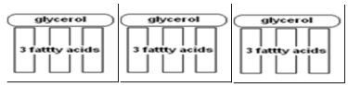 | ________ | _____________________  ___________________  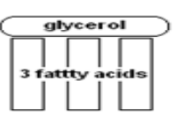 |  | *___________: store body heat  *_________: cell membranes  *___________ energy storage |  | ___________________  ___________________ | _________________  Or  _________________

Nucleic Acids  Found in the cell nucleus  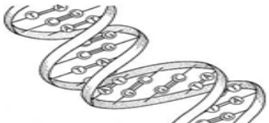 | ________ | _________, ___________, _______________.  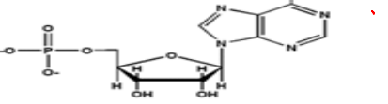 | _____________and__________ genetic information | DNA  _______________________  RNA  _______________________ | No Indicator test  BUT  _________________ is used to see the presence.
Proteins  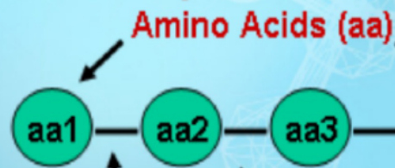 | ________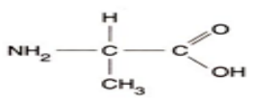 | _______________  *Peptide bonds forming a polypeptide chain (protein) | *Change the rate of ___________ (enzymes)  * ___________  *___________ | *______________-  Ends in “ase”  *Hemoglobin  Carries oxygen in blood. | _________________: blue solution turns violet in proteins
*Fill in EVERYTHING! Macromolecule Chart Organic molecules are based on CARBON.
Elements: C = Carbon, H = hydrogen, N= nitrogen, O= oxygen, P= phosphorus, S= sulfur
Macromolecules,  Biomolecules,  Organic Compunds | Elements | Subunits A-K-A  Monomers A-K-A  Building Blocks | Functions:  Why are they important? | Examples:  Where can we find them? | Test(s)  (Indicators)
Carbohydrates | C,H,O  Carbon, hydrogen, oxygen  Ex:  C₆H₁₂O₆  Glucose (simple sugar) | monosaccharides (simple sugars) | *Short-term energy storage  *Quick-release energy | *Starch -plant  *Glycogen - animal  *Sugars – glucose, fructose, sucrose  *Cellulose – plant cell walls | Iodine: turns purple/blue/black in starch  Benedict’s Solution: turns red, orange or green in simple sugars such as glucose
Lipids: Fats | C,H,O | 1 glycerol and  3 Fatty Acids  =Triglyceride | *Insulation: store body heat  *Protection: cell membranes  *Long-term energy storage | Fats  Oils  Waxes  Steroids  Cholesterol | Brown Paper Bag Test  Or SudanIV
Nucleic Acids  Found in the cell nucleus | C,H,O,N,P | Sugar, Phosphate, Nitrogen base. | Store and transmit genetic information | DNA  Deoxyribonucleic acid  RNA  Ribonucleic acid | No Indicator test  BUT  Gel Electrophoresis is used to see the presence.
Proteins | C,H,N,O, P,S | Amino Acids  *Peptide bonds forming a polypeptide chain (protein) | *Change the rate of chemical reactions (enzymes)  * Structure  *Transport | *Enzymes-  Ends in “ase”  *Hemoglobin | Biuret’s Test: blue solution turns violet in proteins

