_____________________________________ - maintaining a stable internal environment

______________________________ - To make
______________________________ - To move
______________________________ - to get rid of wastes
______________________________ - to make more
______________________________ - to obtain essential molecules and minerals
______________________________ - to grow to maturity
______________________________ - to make energy by using oxygen
______________________________ - to maintain all functions
Beneath each picture, name the cell part and then write the life processes that it provides the cel in order to maintain homeostasis.

- 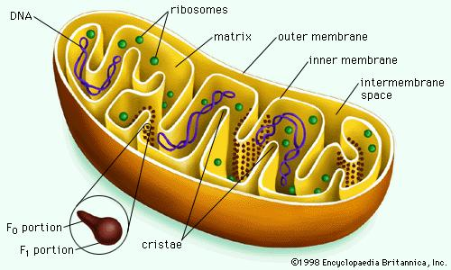 B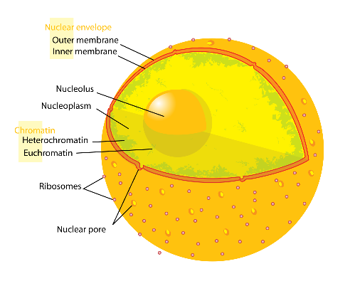

C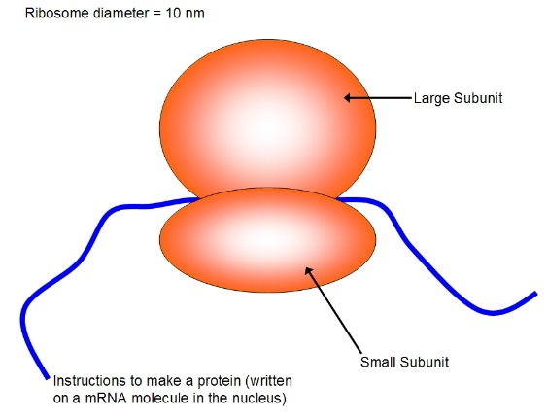 D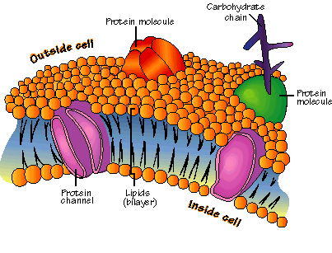

E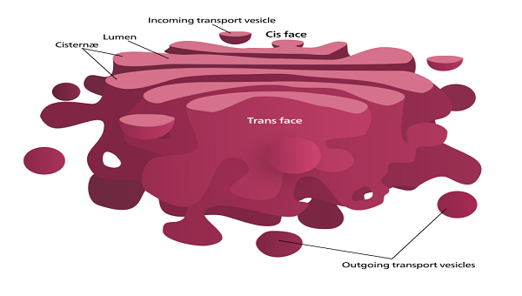 F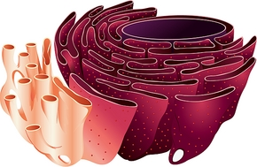

G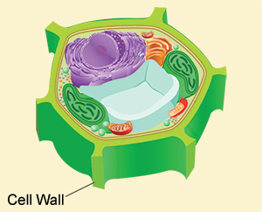 H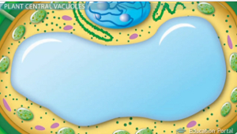

I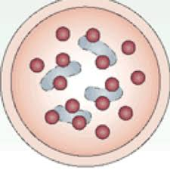 J

