Origins of Life
3.05 Notes #25
- Once thought life came from spontaneous generation, meaning that life comes from nonliving matter. This it the theory of abiogenesis (abio= not living)

- This was disproved by:

  - Redi- experiment to test whether maggots (living) spontaneously generated from meat (dead)

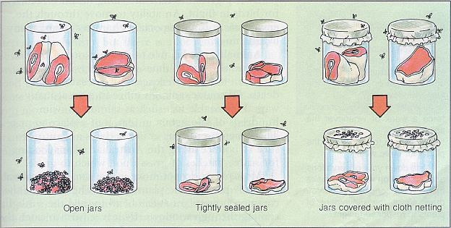
  - Pasteur- used beef broth to prove that microorganisms cannot arise spontaneously.
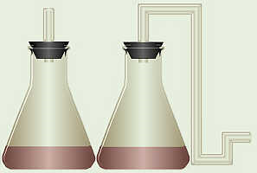

  - Redi and Pasteur’s experiments proved biogenesis: that life only comes from living things

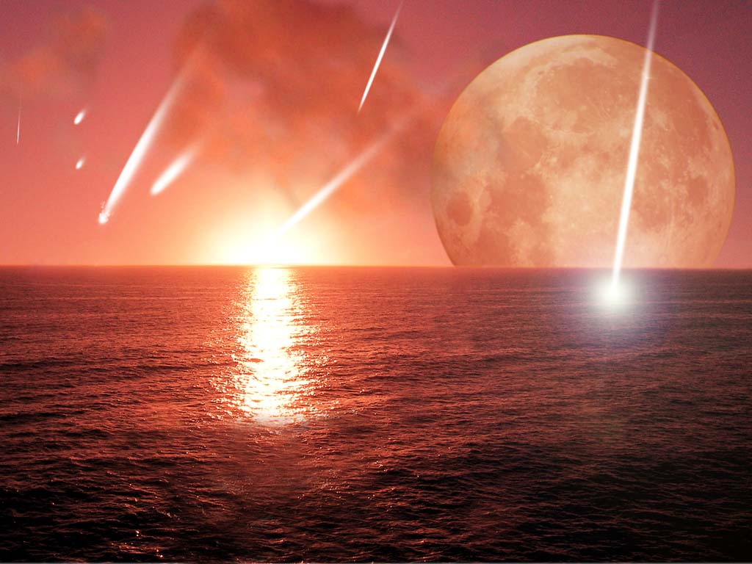
- So…if life has to come from living things, how did life first start???
  - Atmosphere of early Earth contained gases:
      - hydrogen cyanide - nitrogen
      - carbon dioxide - hydrogen
      - carbon monoxide - water
      - hydrogen sulfide
  - Gases reacted with energy from lightning to produce small organic molecules concentrated in primitive oceans.

  - In the 1950’s Miller and Urey filled a flask with hydrogen, methane, ammonia, and water to represent the early Earth and they used electric lightning to stimulate the mixture. In a few days, organic compounds had formed! This suggested that life can be made from simple compounds on the primitive earth.
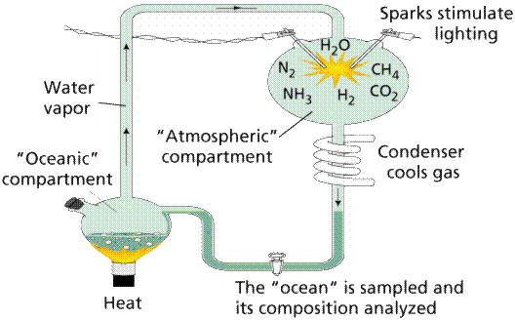
Origins of Cells
- The first true cells were heterotrophic prokaryotes
- They evolved the ability to do photosynthesis to make their own food
- Photosynthetic prokaryotes were responsible for the release of oxygen into the atmosphere
  - Oxygen was toxic to many organisms who died off
- Eukaryotic cells probably arose through a symbiotic relationship between two kinds of prokaryotic cells: We believe that mitochondria and chloroplasts used to be prokaryotes (They have their own DNA)!
  - A photosynthetic bacteria (future chloroplast) and an aerobic heterotroph (future mitochondria) found their home inside the cells

