Osmosis Problems: Will water move in or out of the cell
Environment INSIDE the cell |  | Environment OUTSIDE the cell |  | Water?  In or out
Solute conc | Water Conc. | Solute Conc. | Water Conc. | In or out
20% |  |  | 40%
30% |  | 70%
 | 9% |  | 15%
20% |  |  | 80%
 | 60% | 30%
 | 25% | 25%
60% |  | 50%

- What will happen to a cell placed in distilled water?
- What will happen to a fish put in distilled water?
- What will happen to an egg placed in distilled water?
- What will happen to a cell placed in salt water?
- What will happen to a freshwater fish placed bin salt water?
- What will happen to an egg placed in saltwater?
Below: draw an arrow showing the movement of water.

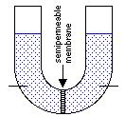
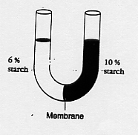
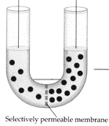
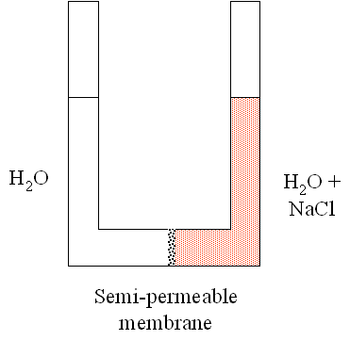

Explain why the inside of the bag will turn black?
