Plants – Eukaryotic, Autotrophic, Sexual, non-motile, have cell wall, multicellular
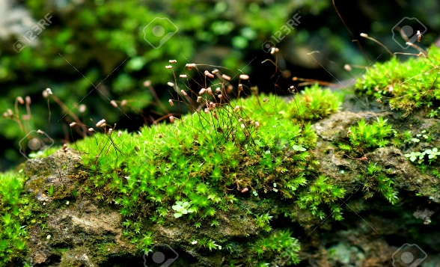
4 classes
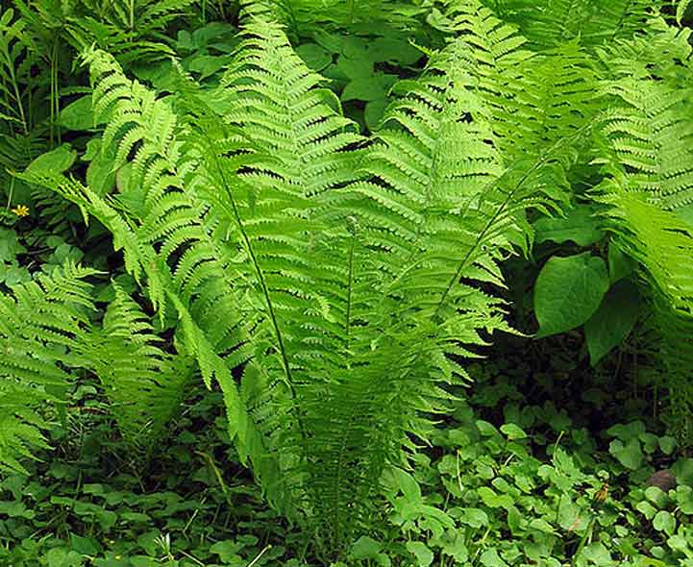
Bryophyta – Moss Pterophyta – Ferns
Seedless, no vascular seedless, vascular
First plants to evolve evolved from moss
Had to grow near water(no roots) have roots, stems, and leaves
Produce spores not seeds produce spores not seeds
Could not grow tall grew tall (because of vascular system)
SORI – where spores are on leaves
FROND – the leaves of a fern

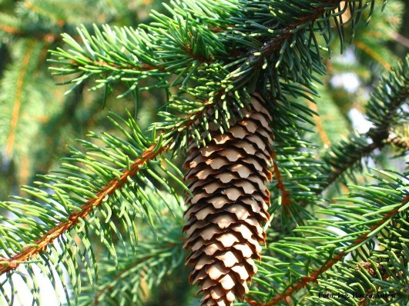
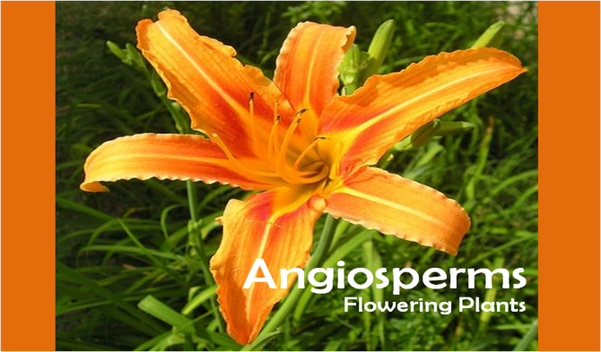
Gymnosperms – pines Angiosperms – flowering plants
First plant with seeds First plants with flowers and fruit
“naked seeds” – pine cones Seed inside fruit
Needles leaves that change color
First to have pollen Flowers to attract insects to pollen

Evolutionary adaptations vocabulary: (classes with adaptation)
Roots – anchor the plant, suck up water (P, G, A) Stems – support the plant in growth up (P, G, A)
Leaves – collect sunlight (P, G, A)
Vascular system – system of cells that transport water and food up and down the plant (P, G, A)
Root hairs – increase surface area for water absorption (P, G, A)
Waxy cuticle – water proof surface of leaves to prevent water loss (A)
Seed – contains the embryo (baby) plant and food for it(G, A)
Pollen – Surrounds sperm of plant prevents it from drying out (G, A)
Stomata – tiny holes in leaf – allow CO₂ in and can close to prevent water loss (A)
Guard cells – open and close stomata to prevent water loss (A)
Fruit – surrounds seed and helps the seed be dispersed (moved) (A)
Flower – attracts insects fro pollination (reproduction) (A)
Plants Need: water, carbon dioxide, sunlight, and need to reproduce. On the back, for each write the adaptation from above that helps plants survive by helping it with its needs.
Water: getting it and keeping it Carbon dioxide: getting it

- 1.

Obtaining Sunlight Reproduction

- 1.
- 2.
3.
4.
Assignment: Make a children’s book. 6 pages. An illustration that highlights the adaptations on each. As you introduce your friends you must develop a story of how they have evolved/adapted. The story line must be consistent with the adaptations.
Page 1: You are the narrator. You are telling the audience that they are going on an adventure to meet new friends called plants. You have to tell them about the general characteristics of this kingdom.
Page 2: Bryophyta: the moss is introducing the audience to him/herself.
Page 3: Pterophyta: the moss is introducing you to a fern and pointing out the adaptations
Page 4: Gymnosperms: the fern is introducing you to his friend the pine tree, pointing out the adaptations
Page 5: Angiosperms: the pine tree is telling you about the angiosperm and its adaptations
Page 6: the angiosperm is telling you why he is so good at reproducing
- What each adaptation does and how it helps must be told.

