- Pollinating is sexual reproduction of flowers
- Hybridization is the mixing of traits
- Incomplete Dominance is the blending of traits red and white make pink
- Law of segregation states that alleles separate independently into each sperm and egg

Law of dominance states that a dominant trait will show up therefore hiding the recessive trait

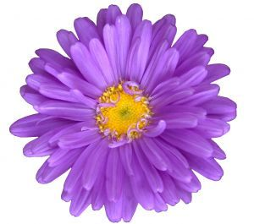
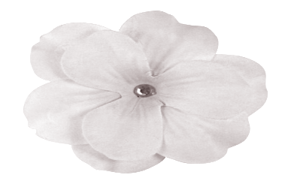
HOMOZYGOUS PURPLE FLOWERS X HOMOZYGOUS WHITE FLOWERS ALL PURPLE FLOWERS

What is the genotype of each

_______________ X _________________ __________________

3:1 ------ that 3 out of 4 show one trait AND 1 out of 4 show the other

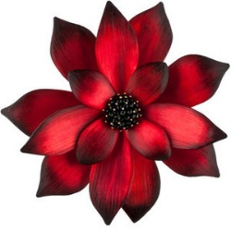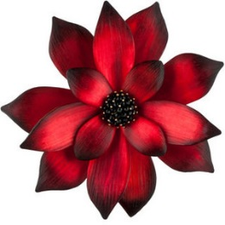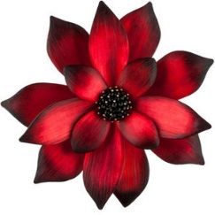

Make an example…………………. T = tall t = short

Write all 3 possible genotypes (possible combinations) and the phenotype (appearance) for each

________ -- _____________________

________ -- ______________________

________ -- ______________________
Make a Punnett square below for each of the following (TT X tt), (Tt X tt) (Tt X Tt)

WHICH cross GIVES a 3:1 phenotypical (appearance)ratio? ____________________________

Homozygous recessive ---------- both “little” letters ------ EXAMPLEs are tt, pp, rr

Heterozygote - different or one of each EXAMPLES are Tt, Pp, Rr

Setting up a Punnett square: when a homozygous recessive is crossed with a heterozygous
Parents = ___________ X ______________

Make Punnett Square

Answer the questions

- What % is heterozygous (ex. Tt or Pp or Rr)
- What % shows the dominant phenotype (the appearance of the dominant trait (Tt,TT or Pp, PP))
- What % shows the homozygous recessive phenotype (ex. tt, or pp or rr)
- What % is homozygous dominant (ex. TT or PP or RR )
- What % is homozygous recessive ( ex. tt, pp, rr)

- ________ b. _______ c. ________ d. _________ e. ________

If P is purple (dominant) p is white then Pp is purple.

This shows the rule of _____________________________________ because purple shows over white

In order to predict the outcome of offspring in a cross………do the following

- Decide on the type of inheritance (dominance, incomplete dominance or codominance)
- Find the genotypes of the parents
- Make a Punnett square
- Analyze the kids in the Punnett square
- Answer the question
If T is tall and dominant over short………….THEN

What letters would denote HOMOZYGOUS DOMINANT - __________

What letters would the genotype of HETEROZYGOUS - __________

What are letters for a HOMOZYGOUS RECESSIVE - ___________

Cross a hybrid (heterozygous) tall plant and a homozygous tall.

Parents = _________ X ___________
What % of tall kids ______________
What % of short kids _____________

Progeny are offspring or kids

A tall human and a short human had a MEDIUM tall baby………….Did the genes……….

- Is this complete dominance of one of the traits? _______

- Is this codominance where both alleles (types) show up? _______________

- Is this incomplete dominance when the traits blend? __________________

RED FLOWERS = RR WHITE FLOWERS = R’R’ PINK FLOWERS = RR’

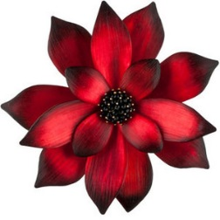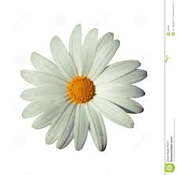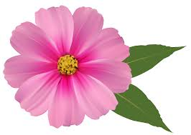
WRITE the GENOTYPES of the following

Homozygous red _________ homozygous white __________ heterozygous ___________

Red flowers ________ white flowers _________ pink flowers __________

In CODOMINANCE in cattle… color is inherited as follows
RR = red hairs

WW = white hairs

RW = red and white hairs together CALLED ROAN

Make 4 punnett squares
- Red X white
- Roan X roan
- White X roan
- Red X roan

GENE EXPRESSION is HOW the genes show up as a physical appearance
- The same genotypes should have the same phenotype (ex. Tt = tall and Tt will be tall)
- Changes in gene expression can be caused by the environment
- ph 2. temperature

