Proteins and Nucleic Acids Notes Name:______________________
Warm-Up
- Which element makes life possible? _____________________________________________________.
- What is the difference between a monomer and a polymer? _________________________________.
- What is a carbohydrate monomer called? ________________________________________________.
- What is a carbohydrate polymer called? _________________________________________________.
- What is a lipid monomer called? _______________________________________________________.
- What is a lipid polymer called? _________________________________________________________________.
Nucleotide Diagram
C) Nucleic Acids

Nucleic Acids are made of ____________________________.
These are composed of three parts:
- ____________________ Made of C, H, and O
- ________________________________ Made of C, H, O, N)
- ____________________ Made of P
Monomer: _________________________________.
There are two types of nucleic acid polymers:
- ____________________________________ (DNA) which is double chained and found in all cells
- ________________________________ (RNA) single stranded chain in cells used to make proteins.
Functions of nucleic acids:
- DNA makes up ___________________. These determine traits, such as ________________________.
- DNA also controls cells activity through the productions of ______________________.
- RNA is also used to ______________________ ______________________.

WORD BANK for Nucleic acid notes
Sugar, Deoxyribonucleic acid, synthesize proteins, nucleotides, nitrogen base, nucleotide, ribonucleic acid, phosphate, genes, proteins, eye color

Proteins
Proteins are made of ______________________ ______________________.
- Made almost entirely of the elements ___________, ___________, ___________, and ___________.
-These are held together by a ______________________ ______________________.
- When these form chains it is called a _______________________________________.
What does an amino acid chain/ protein look like?

-The shape of the proteins determines its function (________________ ________ ____________).
How many amino acids are there? _________________
Monomer: ___________________________________
Functions:
-______________________________ ( Keratin, Collagen)
-______________________________ (Enzymes, antibodies, transport, communication, hormones).
Word bank for proteins:
Polypeptide, amino acids, structural, biological, 22, peptide bond, carbon, hydrogen, oxygen, nitrogen, amino acids
Draw a line matching the structure to the name
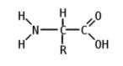
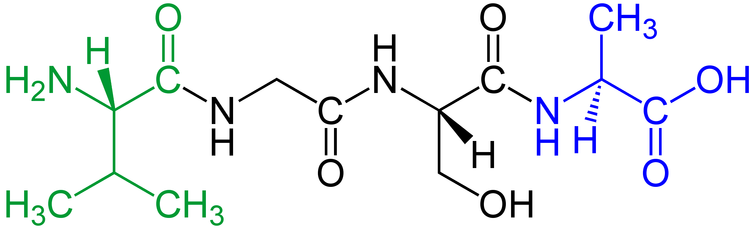
Peptide Polypeptide Dipeptide
