1. 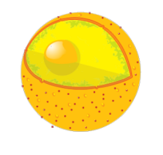
A
2. 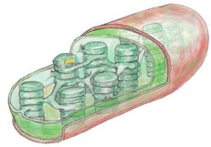

#3-4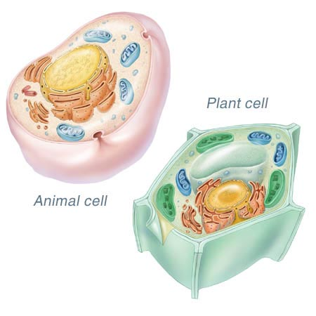
6

3

#9-10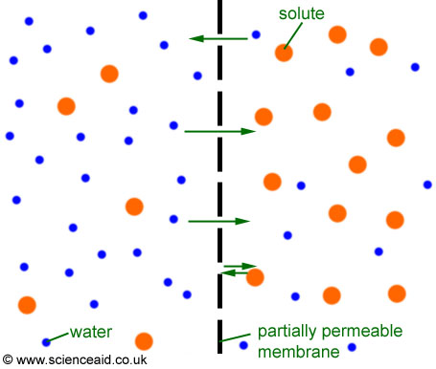
#21
- It is a plant cell, because it has a cell wall.
- It is a bacterium, because it does not have a nucleus.
- It is an animal cell, because it has a flagellum.
- It is impossible to tell from the diagram.

