The plasma membrane / cell membrane / phospholipid bi-layer
Function: separates the inside of the cell from the outside
AND controls what goes in and out of the cell
Membrane vocab:
Phospholipid – molecule made of phosphate and lipids (drawing)
Hydrophilic – water friendly
Hydrophobic – afraid of water
Transport proteins – helps let molecules in or out of cell
Channel proteins – allow molecules to pass through them into or out of the cell
Surface proteins – proteins on the surface of the membrane
Marker proteins – ID the cell
Receptor proteins – receive information
Transport across the membrane
Vocab
Passive Transport – does not need energy
Diffusion – passive transport of molecules from an area of high concentration to an area of low concentration
Osmosis – the diffusion of water
Facilitated diffusion – diffusion from high to low with the help of a protein (passive)
Active transport – movement of molecules across the membrane with the use of energy – movement goes low to high
Sodium-potassium pump – example of active transport
Proton pump – active transport

Study the diagrams of the cell membrane below
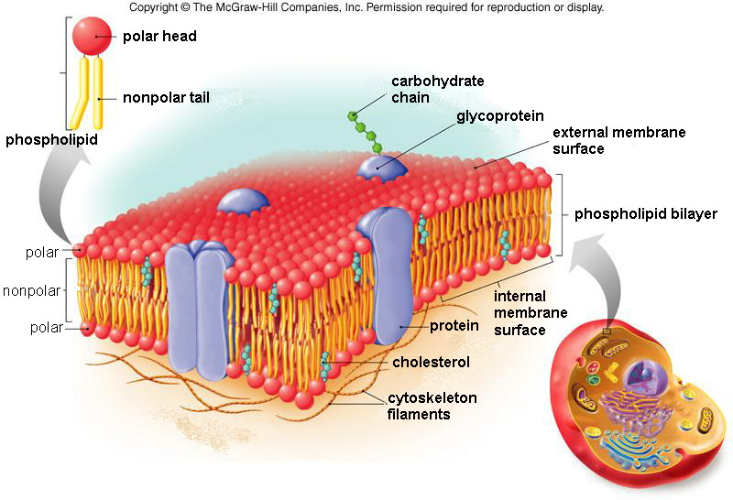
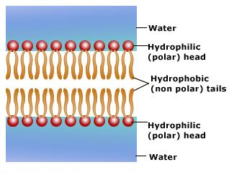

The above diagrams are of the cell membrane. The cell membrane consists of…..
- Phospholipid: phosphate and a lipid
- Proteins

