The structure and function of RNA
- What is the difference between RNA and DNA?
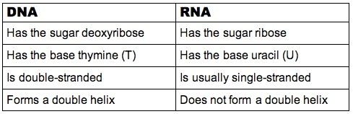
- How many kinds of RNA is there?

A = mRNA B = rRNA C=tRNA
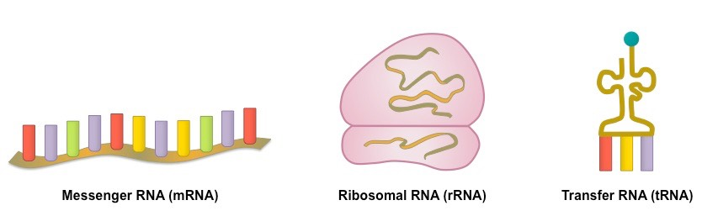
- What are the functions of each?
mRNA – has the codons that code for which amino acids will make up the protein. Carries this code to the ribosomes so the correct proteins can be made
rRNA – makes up ribosomes
tRNA – Carries the amino acids to the ribosomes so they can become a protein. Contains the anticodon.

Practice: Which RNA molecule will
- Transfer amino acids 2. Contains the code 3. Has codons
4. carries amino acids 5. Takes the instructions for proteins to the ribosomes
6. has an anticodon 7. Is shaped like a tee
8. makes up ribosomes

